**Study 2 Results**

**Missing data.**

Table # below shows the number and percentage of missing cases for each of the study’s key variables. Age had the highest percentage of missing cases (9%), while the remaining variables had less than 2% of cases missing. Missing values on these variables were imputed prior to analyses using the `smcfcs` function in R to implement Substantive Model Compatible Fully Conditional Specificationmultiple imputation (discussed in the Planned Analysis section). Five imputed data sets were produced to use in the main analyses.

**Table #**

*Number of Missing Scores per Variable*

| Variable | *N* Missing | % Missing |
| --- | --- | --- |
| Age | 103 | 9.09% |
| Consumer Behaviors | 18 | 1.59% |
| Self-deceptive Enhancement | 15 | 1.32% |
| Impression Management | 14 | 1.24% |
| Biospheric Values | 14 | 1.24% |
| Egoistic Values | 14 | 1.24% |
| Altruistic Values | 13 | 1.15% |
| Hedonic Values | 13 | 1.15% |
| Gender | 0 | 0% |
| In-group Identification | 0 | 0% |
| Clothing Interest | 0 | 0% |
| Framing Condition | 0 | 0% |
| Norm Condition | 0 | 0% |
| Consumer Intentions | 0 | 0% |

*Note.* Total sample size was *n* = 1,133.

Table # shows the final sample size per framing by norm condition. Each combination of framing and norm condition had between 64-91 participants, and there was an average of 75 participants per condition.

**Table #**

*Sample Size per Condition*

|  | Framing Condition | | |  |
| --- | --- | --- | --- | --- |
| Norm Condition | Control | Pro-environmental | Self-enhancing | Total *n* per Norm |
| Control | 79 | 73 | 79 | 231 |
| Descriptive Norm | 71 | 76 | 80 | 227 |
| Convention | 66 | 85 | 77 | 228 |
| Social Norm | 91 | 67 | 64 | 222 |
| Moral Norm | 68 | 80 | 77 | 225 |
| Total *n* per Framing | 375 | 381 | 377 |  |

*Note.* Total sample size was *n* = 1,133.

**Descriptive statistics.**

To understand how participants tended to score on the key variables, I first examined descriptive statistics. Descriptive statistics for the variables with no missing data are provided in Table #. For variables with missing data, descriptive statistics are provided in Table # and Table # across each imputed data set. Descriptive statistics for variables with missing data were similar across imputed data sets.

As shown in the descriptive statistics tables and the histograms in Figure #, scores on each variable tended to be approximately normally distributed and centered around the midpoint of each scale with the exception of biospheric values, altruistic values, hedonic values, and age. Scores on biospheric values, altruistic values, and hedonic values were substantially negatively skewed. This indicates that the sample highly endorsed these values and there was not much representation of individuals who score below the midpoint on these scales. Age was also substantially positively skewed with the large majority of the sample being between the ages of 18 and 25.

**Table #**

*Descriptive Statistics for Continuous Variables with No Missing Data*

| Variable | *n* | *M* | *SD* | *Skew* | *Min* | *Max* | *Mdn* |
| --- | --- | --- | --- | --- | --- | --- | --- |
| Clothing Interest | 1133 | 3.13 | 0.80 | -0.18 | 1 | 5 | 3.15 |
| In-group Identification | 1133 | 4.64 | 1.01 | -0.27 | 1 | 7 | 4.64 |
| Consumer Intentions | 1133 | 4.41 | 1.19 | -0.16 | 1 | 7 | 4.44 |

**Table #**

*Descriptive Statistics for Continuous Variables with Missing Data across Each Imputed Set*

| Imputed Set | Variable | Original *n* | *# of Imputed* | *M* | *SD* | *Skew* | *Min* | *Max* | *Mdn* |
| --- | --- | --- | --- | --- | --- | --- | --- | --- | --- |
| 1 | Biospheric Values | 1,119 | 14 | 5.85 | 1.00 | -1.08 | 1 | 7 | 6 |
| Altruistic Values | 1,120 | 13 | 6.21 | 0.80 | -1.91 | 1 | 7 | 6.50 |
| Egoistic Values | 1,119 | 14 | 5.00 | 0.92 | -0.39 | 1 | 7 | 5 |
| Hedonic Values | 1,120 | 13 | 6.05 | 0.79 | -1.44 | 1 | 7 | 6.33 |
| Self-deceptive Enhancement | 1,118 | 15 | 3.72 | 0.85 | 0.14 | 1 | 7 | 3.72 |
| Impression Management | 1,119 | 14 | 4.01 | 0.85 | 0.26 | 1 | 7 | 4 |
| Age | 1,030 | 103 | 19.8 | 1.93 | 4.65 | 18 | 50 | 19.18 |
| 2 | Biospheric Values | 1,119 | 14 | 5.85 | 0.99 | -1.08 | 1 | 7 | 6 |
| Altruistic Values | 1,120 | 13 | 6.20 | 0.81 | -1.89 | 1 | 7 | 6.50 |
| Egoistic Values | 1,119 | 14 | 4.99 | 0.92 | -0.38 | 1 | 7 | 5 |
| Hedonic Values | 1,120 | 13 | 6.05 | 0.80 | -1.43 | 1 | 7 | 6.33 |
| Self-deceptive Enhancement | 1,118 | 15 | 3.72 | 0.86 | 0.15 | 1 | 7 | 3.72 |
| Impression Management | 1,119 | 14 | 4.01 | 0.85 | 0.26 | 1 | 7 | 4 |
| Age | 1,119 | 14 | 19.87 | 1.93 | 4.68 | 18 | 50 | 19 |
| 3 | Biospheric Values | 1,119 | 14 | 5.85 | 1.00 | -1.10 | 1 | 7 | 6 |
| Altruistic Values | 1,120 | 13 | 6.21 | 0.81 | -1.91 | 1 | 7 | 6.50 |
| Egoistic Values | 1,119 | 14 | 5.00 | 0.92 | -0.39 | 1 | 7 | 5 |
| Hedonic Values | 1,120 | 13 | 6.05 | 0.79 | -1.44 | 1 | 7 | 6.33 |
| Self-deceptive Enhancement | 1,118 | 15 | 3.72 | 0.85 | 0.16 | 1 | 7 | 3.72 |
| Impression Management | 1,119 | 14 | 4.01 | 0.85 | 0.25 | 1 | 7 | 4 |
| Age | 1,119 | 14 | 19.90 | 1.94 | 4.57 | 18 | 50 | 19.29 |
| 4 | Biospheric Values | 1,119 | 14 | 5.85 | 0.99 | -1.10 | 1 | 7 | 6 |
| Altruistic Values | 1,120 | 13 | 6.21 | 0.81 | -1.90 | 1 | 7 | 6.50 |
| Egoistic Values | 1,119 | 14 | 5.00 | 0.92 | -0.40 | 1 | 7 | 5 |
| Hedonic Values | 1,120 | 13 | 6.06 | 0.79 | -1.45 | 1 | 7 | 6.33 |
| Self-deceptive Enhancement | 1,118 | 15 | 3.72 | 0.85 | 0.12 | 1 | 7 | 3.72 |
| Impression Management | 1,119 | 14 | 4.00 | 0.85 | 0.24 | 1 | 7 | 4 |
| Age | 1,119 | 14 | 19.88 | 1.94 | 4.63 | 18 | 50 | 19 |
| 5 | Biospheric Values | 1,119 | 14 | 5.85 | 1.00 | -1.11 | 1 | 7 | 6 |
| Altruistic Values | 1,120 | 13 | 6.21 | 0.81 | -1.91 | 1 | 7 | 6.50 |
| Egoistic Values | 1,119 | 14 | 4.99 | 0.92 | -0.39 | 1 | 7 | 5 |
| Hedonic Values | 1,120 | 13 | 6.05 | 0.79 | -1.45 | 1 | 7 | 6.33 |
| Self-deceptive Enhancement | 1,118 | 15 | 3.72 | 0.86 | 0.15 | 1 | 7 | 3.72 |
| Impression Management | 1,119 | 14 | 4.00 | 0.85 | 0.26 | 1 | 7 | 4 |
| Age | 1,119 | 14 | 19.89 | 1.92 | 4.69 | 18 | 50 | 19.14 |

**Table #**

*Descriptive Statistics for Consumer Behaviors across Each Imputed Set*

| Imputed Set | Original *n* | *# of Imputed* | *n*NewClothing | *n*Secondhandclothing |
| --- | --- | --- | --- | --- |
| 1 | 1,115 | 18 | 608 | 525 |
| 2 | 1,115 | 18 | 605 | 528 |
| 3 | 1,115 | 18 | 606 | 527 |
| 4 | 1,115 | 18 | 606 | 527 |
| 5 | 1,115 | 18 | 603 | 530 |

**Figure #**

***

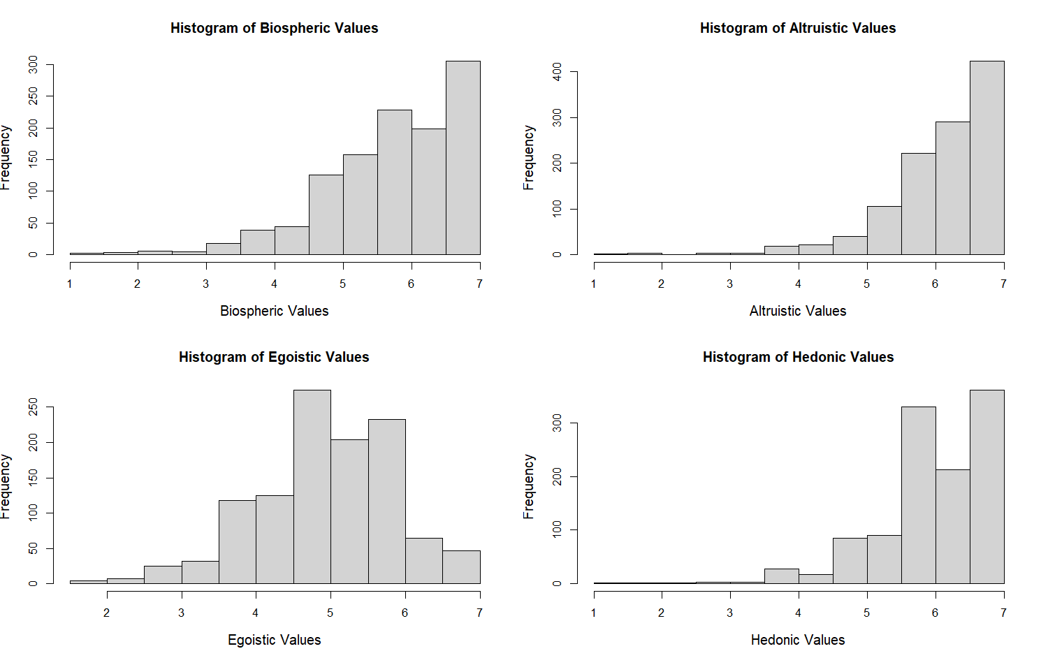

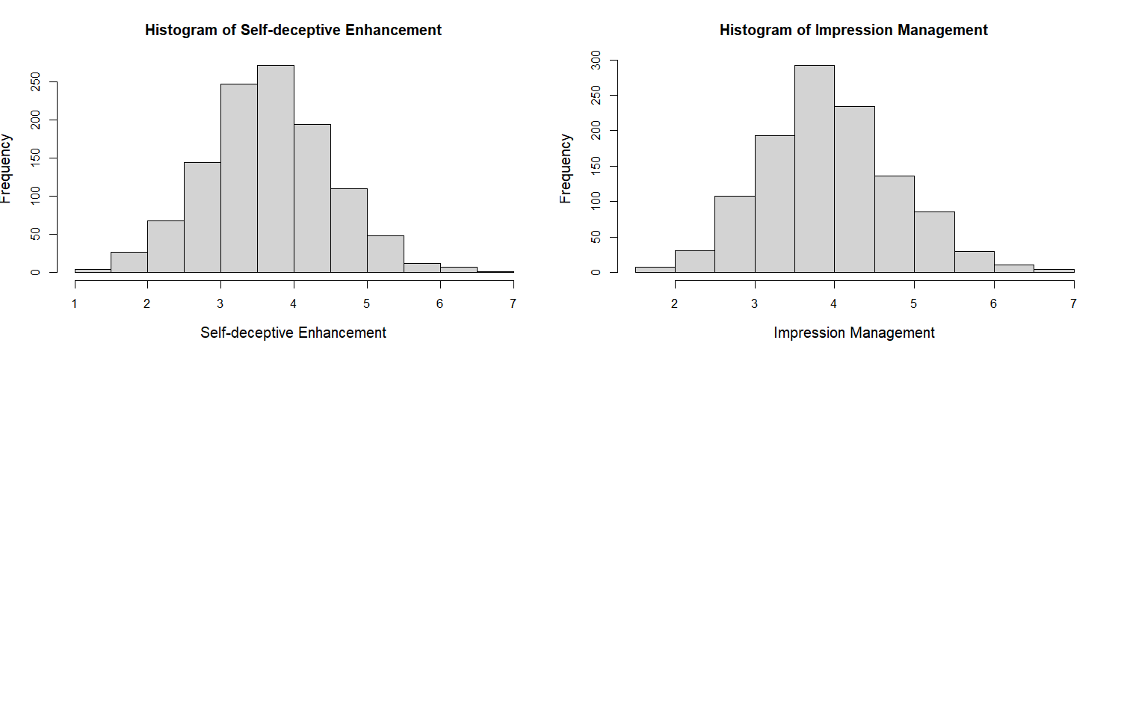

To produce a correlation matrix, the `micombine.cor` function was used in R to pool the correlation estimates across the five imputed data sets. The results are shown in Table #. The largest correlations were between biospheric and altruistic values, *r* = 0.66, hedonic and biospheric values, *r* = 0.36, hedonic and altruistic values, *r* = 0.47, and hedonic and egoistic values, *r* = 0.44. The remaining correlations were 0.30 or lower. Overall, there did not appear to be an issue of high correlations between predictors.

**Table #**

*Pooled Correlation Matrix*

|  | Biospheric | Altruistic | Egoistic | Hedonic | In-group Identification | | Clothing Interest | Self-deceptive Enhancement | Impression Management | Age | Consumer Intentions |
| --- | --- | --- | --- | --- | --- | --- | --- | --- | --- | --- | --- |
| Biospheric | 1.00 |  |  |  | |  |  |  |  |  |  |
| Altruistic | 0.66 | 1.00 |  |  | |  |  |  |  |  |  |
| Egoistic | 0.16 | 0.23 | 1.00 |  | |  |  |  |  |  |  |
| Hedonic | 0.36 | 0.47 | 0.44 | 1.00 | |  |  |  |  |  |  |
| In-group Identification | 0.10 | 0.15 | 0.14 | 0.13 | | 1.00 |  |  |  |  |  |
| Clothing Interest | 0.14 | 0.17 | 0.22 | 0.15 | | 0.13 | 1.00 |  |  |  |  |
| Self-deceptive Enhancement | -0.02 | -0.03 | 0.20 | 0.08 | | 0.03 | 0.05 | 1.00 |  |  |  |
| Impression Management | 0.05 | 0.10 | -0.05 | -0.10 | | 0.01 | -0.06 | 0.30 | 1.00 |  |  |
| Age | -0.10 | -0.16 | -0.01 | -0.08 | | -0.16 | -0.14 | 0.18 | 0.08 | 1.00 |  |
| Consumer Intentions | 0.30 | 0.19 | -0.23 | -0.03 | | 0.05 | 0.01 | -0.15 | 0.01 | -0.13 | 1.00 |

**Linear Regression Analysis for Pro-environmental****Consumer Intentions.**

A linear regression analysis was performed to analyze the effects of framing condition, norm condition, values, in-group identification, and the interaction effects between these predictors on pro-environmental consumer intentions while also controlling for socially desirable responding, interest in clothing, gender, and age. To perform the analysis using the multiply imputed data, the `lm` function was used in tandem with the `with` function in R. Together, these functions perform the regression analysis on each of the five imputed data sets when passed the mids object created by the `smcfcs` function. Then, the `pool` function was used to aggregate the final results across the five individual models. The `mi.anova` function was used to produce an ANOVA table of these pooled results, which is shown in Table #.

**Table 2**

*Pooled ANOVA Table for Model Predicting Pro-environmental Consumer Intentions*

|  | *SS* | *df1* | *df2* | *F* | *p* | η2 | ηp2 |
| --- | --- | --- | --- | --- | --- | --- | --- |
| Framing Condition | 4.45 | 2 | 277911.15 | 1.94 | 0.144 | 0.003 | 0.004 |
| Norm Condition | 6.52 | 4 | 71957.17 | 1.41 | 0.227 | 0.005 | 0.005 |
| Biospheric Values | 69.70 | 1 | 182541.21 | 60.76 | <.001 | 0.048 | 0.056 |
| Altruistic Values | 1.79 | 1 | 4948.63 | 1.48 | 0.224 | 0.001 | 0.002 |
| Egoistic Values | 55.16 | 1 | 117647.58 | 48.03 | <.001 | 0.038 | 0.044 |
| Hedonic Values | 3.39 | 1 | 10965.18 | 2.88 | 0.090 | 0.002 | 0.003 |
| Ingroup Identification | 0.80 | 1 | 15534.19 | 0.67 | 0.413 | 0.001 | 0.001 |
| Self-deceptive Enhancement | 7.50 | 1 | 10820.41 | 6.41 | 0.011 | 0.005 | 0.006 |
| Impression Management | 0.15 | 1 | 48583.18 | 0.12 | 0.732 | 0.000 | 0.000 |
| Clothing Interest | 0.01 | 1 | 3781093.85 | 0.01 | 0.942 | 0.000 | 0.000 |
| Gender | 4.35 | 1 | 2572.87 | 3.60 | 0.058 | 0.003 | 0.004 |
| Age | 5.96 | 1 | 71.04 | 3.63 | 0.061 | 0.004 | 0.005 |
| Framing x Norm | 5.70 | 8 | 55071.52 | 0.61 | 0.767 | 0.004 | 0.005 |
| Framing x Biospheric Values | 0.74 | 2 | 3277.29 | 0.27 | 0.761 | 0.001 | 0.001 |
| Norm x Biospheric Values | 11.75 | 4 | 97395.31 | 2.56 | 0.037 | 0.008 | 0.010 |
| Framing x Altruistic Values | 1.29 | 2 | 6519.70 | 0.52 | 0.592 | 0.001 | 0.001 |
| Norm x Altruistic Values | 9.15 | 4 | 9084.58 | 1.96 | 0.098 | 0.006 | 0.008 |
| Framing x Egoistic Values | 0.48 | 2 | 15139.30 | 0.19 | 0.831 | 0.000 | 0.000 |
| Norm x Egoistic Values | 2.16 | 4 | 8536.54 | 0.44 | 0.776 | 0.001 | 0.002 |
| Framing x Hedonic Values | 2.18 | 2 | 21454.97 | 0.93 | 0.396 | 0.002 | 0.002 |
| Norm x Hedonic Values | 8.19 | 4 | 22945.86 | 1.76 | 0.133 | 0.006 | 0.007 |
| Framing x Ingroup Identification | 0.88 | 2 | 493256.84 | 0.38 | 0.685 | 0.001 | 0.001 |
| Norm x Ingroup Identification | 1.08 | 4 | 363457.46 | 0.23 | 0.920 | 0.001 | 0.001 |
| Framing x Norm x Biospheric Values | 17.32 | 8 | 345248.97 | 1.89 | 0.057 | 0.012 | 0.014 |
| Framing x Norm x Altruistic Values | 11.73 | 8 | 16665.70 | 1.26 | 0.259 | 0.008 | 0.010 |
| Framing x Norm x Egoistic Values | 11.33 | 8 | 28094.95 | 1.22 | 0.280 | 0.008 | 0.009 |
| Framing x Norm x Hedonic Values | 6.00 | 8 | 5510.08 | 0.63 | 0.757 | 0.004 | 0.005 |
| Framing x Norm x Ingroup Identification | 13.04 | 8 | 13143.09 | 1.40 | 0.190 | 0.009 | 0.011 |
| Residual | 1184.90 |  |  |  |  |  |  |

The `mi.anova` function calculates the denominator degrees of freedom for multiply imputed data using the formula *K*-3/*M*(*M* – 1)(1 + ARIV-1)2 where *K* is the numerator degrees of freedom, *M* is the number of multiple imputations performed, and ARIV is the average relative increase in variance due to the presence of missing data. For an accessible discussion of how these degrees of freedom are calculated, see Grund, Lüdtke, and Robitzsch (2016), and for the original derivation of the degrees of freedom formula, see Li et al. (1991).

Regression diagnostics were performed by examining the residuals from each of the five individually fitted models. Residuals plots were produced using the `plot` function in R, and a distribution of the residuals was created using `ggplot`. Examinations of the residuals plots across each fitted model indicated no issues with non-linearity or heteroscedasticity. Additionally, residuals appeared to be approximately normally distributed across each model. The `ols_vif_tol` function was used to examine multicollinearity among the predictors in the model. All tolerances were above 0.20 and VIFs were below 5, indicating no issues with multicollinearity.

***Main effect of framing condition.***

The overall effect of framing condition was not significant in the above model, *F*(2, 277911.15) = 1.94, *p* = .144, ηp2 = .004. Because there was an a priori hypothesis regarding how specific levels of framing condition compare to one another, this effect was still followed up by simple effects analyses. Estimated marginal means (EMMs) were calculated using the `emmeans` function in R. Table # shows the EMMs for each level of framing condition. These EMMs are also visually depicted in Figure #.

**Table 8**

*Estimated Marginal Means for Pro-environmental Consumer Intentions Across Framing Conditions*

| Framing Condition | *EMM* | *SE* | *df* | *95%CI EMM* |
| --- | --- | --- | --- | --- |
| Control Framing | 4.33 | 0.06 | 1038 | [4.21, 4.44] |
| Pro-environmental Framing | 4.48 | 0.06 | 1038 | [4.37, 4.59] |
| Self-enhancing Framing | 4.36 | 0.06 | 1038 | [4.25, 4.47] |

**Figure #**

*Visualization of the EMMs for Pro-environmental Consumer Intentions Across Framing Conditions*

*Note.* Bars represent 95%CIs around each EMM.

To compare EMMs across conditions, the `contrast` function was used in R, along with the `confint` and `eff_size` functions to produce confidence intervals and effect sizes. As shown in Table #, unlike what was predicted by hypothesis 1, pro-environmental consumer intentions were highest in the pro-environmental framing condition, but its differences from the control framing condition, *t*(1038) = 1.87, *p* = .062, *d* = 0.14, and the self-enhancing framing condition, *t*(1038) = 1.46, *p* = .145, *d* = 0.11, were both non-significant. The difference between the self-enhancing framing and the control framing condition was also non-significant and the effect size was close to zero, *t*(1038) = 0.41, *p* = .679, *d* = 0.03.

**Table 9**

*Comparison of Pro-environmental Consumer Intentions Between Framing Conditions*

| Contrast of  Framing Conditions | *EMM Difference* | *95%CI*  *EMM Difference* | *SE* | *df* | *t* | *p* | *Cohen’s d* |
| --- | --- | --- | --- | --- | --- | --- | --- |
| SE vs Control | 0.03 | [-0.13, 0.19] | 0.08 | 1038 | 0.41 | 0.679 | 0.03 |
| PE vs Control | 0.15 | [-0.01, 0.31] | 0.08 | 1038 | 1.87 | 0.062 | 0.14 |
| PE vs SE | 0.12 | [-0.28, 0.04] | 0.08 | 1038 | 1.46 | 0.145 | 0.11 |

*Note.* SE = self-enhancing framing, PE = pro-environmental framing

***Main effect of norm condition.***

The main effect of norm condition was not significant in the overall model, *F*(4, 71957.17) = 1.41, *p* = .227, ηp2 = .005. Because there was an a priori hypothesis regarding how specific levels of norm condition compare to one another, this effect was still followed up by simple effects analyses. Table # shows the EMMs for each level of norm condition, which are also visually depicted in Figure # below.

**Table #**

*Estimated Marginal Means for Pro-environmental Consumer Intentions Across Norm Conditions*

| Framing Condition | *EMM* | *SE* | *df* | *95%CI EM Mean* |
| --- | --- | --- | --- | --- |
| Control Norm | 4.43 | 0.07 | 1038 | [4.29, 4.58] |
| Descriptive Norm | 4.40 | 0.07 | 1038 | [4.26, 4.55] |
| Convention | 4.50 | 0.07 | 1038 | [4.36, 4.65] |
| Social Norm | 4.28 | 0.08 | 1038 | [4.13, 4.42] |
| Moral Norm | 4.33 | 0.08 | 1038 | [4.18, 4.48] |

**Figure #**

*Visualization of the EMMs for Pro-environmental Consumer Intentions Across Norm Conditions*

*Note.* Bars represent 95%CIs around each EMM.

The effect of each norm-intervention condition was defined as the difference in pro-environmental consumer intentions between each norm-intervention condition and the control norm condition. As shown in Table #, unlike what was predicted by hypothesis 2, pro-environmental consumer intentions were only higher than the control norm condition in the convention condition, though the difference was non-significant, *t*(1038) = 0.68, *p* = .499, *d* = 0.07. Pro-environmental consumer intentions were non-significantly lower in the social norm, *t*(1038) = -1.50, *p* = .134, *d* = 0.15, and moral norm, *t*(1038) = -1.00, *p* = .320, *d* = 0.10, conditions compared to the control norm condition. The difference in pro-environmental consumer intentions between the descriptive and control norm condition was non-significant and the effect size was close to zero, *t*(1038) = -0.29, *p* = .774, *d* = 0.03.

**Table 11**

*Comparison of Pro-environmental Consumer Intentions Between Norm Conditions*

| Contrast of Norm Conditions | *EMM Difference* | *95%CI*  *EMM Difference* | *SE* | *df* | *t* | *p* | *Cohen’s d* |
| --- | --- | --- | --- | --- | --- | --- | --- |
| Descriptive vs Control | -0.03 | [-0.22, 0.17] | 0.10 | 1038 | -0.29 | 0.774 | 0.03 |
| Convention vs Control | 0.07 | [-0.13, 0.27] | 0.10 | 1038 | 0.68 | 0.499 | 0.07 |
| Social vs Control | -0.16 | [-0.36, 0.05] | 0.10 | 1038 | -1.50 | 0.134 | 0.15 |
| Moral vs Control | -0.10 | [-0.31, 0.10] | 0.10 | 1038 | -1.00 | 0.320 | 0.10 |

***Framing by norm interaction effect.***

The framing by norm interaction effect was not significant in the overall model, *F*(8, 55071.52) = 0.61, *p* = .767, ηp2 = .005. This finding is inconsistent with what was predicted by hypothesis 3. However, because there was an a priori hypothesis regarding this two-way interaction, simple effects analyses were performed to better understand the nature (or the reason for the lack of) this interaction effect. Table # displays the EMMs for each combination of framing and norm condition. These EMMs are also visually depicted in Figure #.

**Table #**

*Estimated Marginal Means for Pro-environmental Consumer Intentions Across Framing and Norm Conditions*

|  | Framing Condition | | |  |
| --- | --- | --- | --- | --- |
|  | Control | Pro-environmental | Self-enhancing | Per Norm Condition |
| Norm Condition | *EMM* (*SE*) | *EMM* (*SE*) | *EMM* (*SE*) | *EMM* (*SE*) |
| Control | 4.45 (0.12) | 4.61 (0.13) | 4.24 (0.13) | 4.43 (0.07) |
| Descriptive Norm | 4.29 (0.13) | 4.44 (0.13) | 4.47 (0.12) | 4.40 (0.07) |
| Convention | 4.50 (0.14) | 4.54 (0.12) | 4.47 (0.13) | 4.50 (0.07) |
| Social Norm | 4.16 (0.12) | 4.42 (0.13) | 4.24 (0.14) | 4.28 (0.08) |
| Moral Norm | 4.23 (0.14) | 4.38 (0.12) | 4.38 (0.13) | 4.33 (0.08) |
| Per Framing Condition | 4.33 (0.06) | 4.48 (0.06) | 4.36 (0.06) |  |

*Note.* This table displays EMMs resulting from the regression model detailed in Table #. Standard errors are provided in parentheses.

**Figure #**

*Visualization of the EMMs for Pro-environmental Consumer Intentions Across Framing and Norm Conditions*

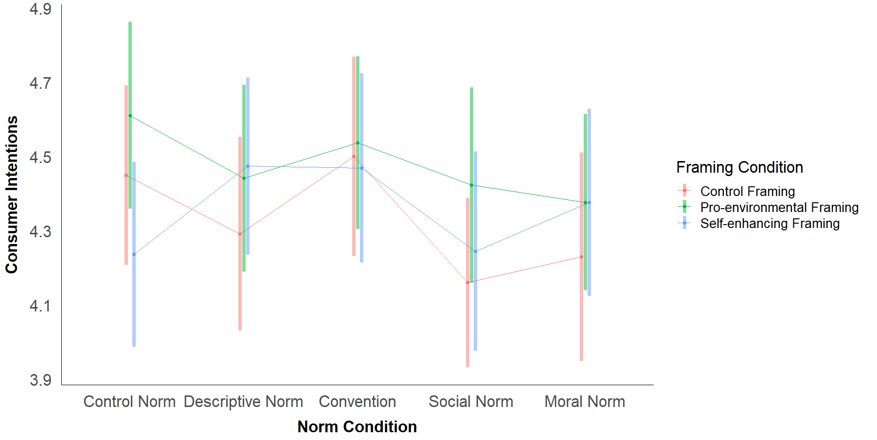

To better understand the framing by norm interaction effect, the effect of each norm-intervention condition was examined separately within each framing condition. The results are shown in Table # below. The pattern of effects for each norm-intervention condition were similar when no framing context was provided and when a pro-environmental framing context was provided. In both cases, exposure to the descriptive norm, social norm, and moral norm conditions appeared to non-significantly decrease pro-environmental consumer intentions compared to the control norm condition, and the convention condition had little to no effect on consumer intentions.

When a self-enhancing framing context was provided, unlike the pattern observed for the other two framing conditions, pro-environmental consumer intentions were non-significantly higher in the descriptive norm, convention, and moral norm conditions compared to the control norm condition, and there was little to no effect of the social norm condition. This different pattern of effects observed within the self-enhancing framing condition could be due to the fact that the EMM for the control norm condition paired with the self-enhancing framing had the lowest EMM of the three control norm conditions.

**Table #**

*Effect of Each Norm Condition on Pro-environmental Consumer Intentions Across Framing Conditions*

| Framing Condition | Contrast of Norm Conditions | *EMM Difference* | *95%CI  EMM Difference* | *SE* | *df* | *t* | *p* | *Cohen’s d* |
| --- | --- | --- | --- | --- | --- | --- | --- | --- |
| Control | Descriptive vs Control | -0.16 | [-0.51, 0.20] | 0.18 | 1038 | -0.87 | 0.384 | 0.15 |
| Convention vs Control | 0.05 | [-0.31, 0.41] | 0.18 | 1038 | 0.27 | 0.783 | 0.05 |
| Social vs Control | -0.29 | [-0.62, 0.04] | 0.17 | 1038 | -1.71 | 0.088 | 0.27 |
| Moral vs Control | -0.22 | [-0.59, 0.15] | 0.19 | 1038 | -1.16 | 0.246 | 0.21 |
| PE | Descriptive vs Control | -0.17 | [-0.52, 0.19] | 0.18 | 1038 | -0.94 | 0.349 | 0.16 |
| Convention vs Control | -0.07 | [-0.42, 0.27] | 0.17 | 1038 | -0.42 | 0.671 | 0.07 |
| Social vs Control | -0.19 | [-0.55, 0.18] | 0.19 | 1038 | -1.02 | 0.310 | 0.18 |
| Moral vs Control | -0.23 | [-0.58, 0.11] | 0.18 | 1038 | -1.33 | 0.183 | 0.22 |
| SE | Descriptive vs Control | 0.24 | [-0.11, 0.58] | 0.18 | 1038 | 1.36 | 0.174 | 0.22 |
| Convention vs Control | 0.23 | [-0.12, 0.59] | 0.18 | 1038 | 1.29 | 0.198 | 0.22 |
| Social vs Control | 0.01 | [-0.36, 0.38] | 0.19 | 1038 | 0.05 | 0.962 | 0.01 |
| Moral vs Control | 0.14 | [-0.21, 0.49] | 0.18 | 1038 | 0.78 | 0.435 | 0.13 |

*Note.* PE = Pro-environmental framing, SE = self-enhancing framing

Although the self-enhancing framing context was the only one in which three of the norm-intervention conditions had higher EMMs compared to the control norm condition, this could be less the result of pro-environmental consumer intentions being much improved when paired with the self-enhancing framing, and more to do with the EMM for the control norm condition within the self-enhancing framing condition starting out lower than the EMM for the other two control norm conditions. Thus, this finding was followed up by simple effects analyses comparing the EMMs for the same norm-intervention condition across all three framing contexts.

As shown in Table #, pro-environmental consumer intentions were significantly lower when the control norm was paired with a self-enhancing framing than when the control norm was paired with a pro-environmental framing, *t*(1038) = 2.08, *p* = .037, *d* = 0.35. The other differences in EMMs for each norm-intervention condition between the three framing contexts were non-significant.

Although the differences in the EMMs for the remaining norm-intervention condition across the three framing conditions were non-significant, there are still some interesting observations worth noting. Earlier, when looking at the overall effect of norm condition, the convention condition had the highest EMM followed by the control norm condition (though the difference between the two was non-significant). Although the overall EMMs for these two conditions were very similar, based on Figure #, there appears to also be less variability in pro-environmental consumer intentions across the three framing contexts when a convention normative message was used compared to when no normative message was given.

Additionally, though non-significant, pro-environmental consumer intentions were, on average, lower in the descriptive, social, and moral norm conditions compared to the control norm condition. Although non-significant, based on effect sizes, this decrease appears to be greatest when these norm-intervention conditions were prefaced by no framing context than when these norm-intervention conditions were prefaced by the pro-environmental or self-enhancing framing contexts.

**Table #**

*Differences in Pro-environmental Consumer Intentions for Each Norm Condition Across Framings*

| Norm Condition | Contrast of  Framing Conditions | *EMM Difference* | *95% EMM Difference* | *SE* | *df* | *t* | *p* | *Cohen’s d* |
| --- | --- | --- | --- | --- | --- | --- | --- | --- |
| Control norm | PE vs C | 0.16 | [-0.19, 0.51] | 0.18 | 1038 | 0.91 | 0.364 | 0.15 |
| SE vs C | -0.21 | [-0.56, 0.13] | 0.18 | 1038 | -1.21 | 0.227 | 0.20 |
| PE vs SE | 0.38 | [0.02, 0.73] | 0.18 | 1038 | 2.08 | 0.037 | 0.35 |
| Descriptive Norm | PE vs C | 0.15 | [-0.21, 0.51] | 0.18 | 1038 | 0.81 | 0.418 | 0.14 |
| SE vs C | 0.18 | [-0.17, 0.53] | 0.18 | 1038 | 1.02 | 0.310 | 0.17 |
| PE vs SE | -0.03 | [-0.38, 0.31] | 0.18 | 1038 | -0.18 | 0.854 | 0.03 |
| Convention | PE vs C | 0.04 | [-0.32, 0.39] | 0.18 | 1038 | 0.20 | 0.838 | 0.03 |
| SE vs C | -0.03 | [-0.40, 0.34] | 0.19 | 1038 | -0.16 | 0.872 | 0.03 |
| PE vs SE | 0.07 | [-0.28, 0.41] | 0.18 | 1038 | 0.38 | 0.701 | 0.06 |
| Social Norm | PE vs C | 0.26 | [-0.08, 0.61] | 0.18 | 1038 | 1.48 | 0.138 | 0.25 |
| SE vs C | 0.08 | [-0.27, 0.44] | 0.18 | 1038 | 0.47 | 0.637 | 0.08 |
| PE vs SE | 0.18 | [-0.20, 0.55] | 0.19 | 1038 | 0.93 | 0.351 | 0.17 |
| Moral Norm | PE vs C | 0.15 | [-0.22, 0.51] | 0.19 | 1038 | 0.78 | 0.433 | 0.14 |
| SE vs C | 0.15 | [-0.23, 0.52] | 0.19 | 1038 | 0.76 | 0.447 | 0.14 |
| PE vs SE | 0.00 | [-0.35, 0.35] | 0.18 | 1038 | 0.00 | 0.999 | 0.00 |

*Note*. C = control framing, PE = pro-environmental framing, SE = self-enhancing framing

***Values interaction effects.***

**Biospheric values.** In the overall model, biospheric values significantly predicted pro-environmental consumer behaviors, *F*(1, 182541.21) = 60.76, *p* < .001, ηp2 = .056. On average, participants high (+1SD above the mean) on biospheric values scored significantly higher on pro-environmental consumer intentions (*EMM* = 4.75, *SE* = 0.06) compared to participants low (-1SD below the mean) on biospheric values (*EMM* = 4.03, *SE* = 0.06), *t*(1038) = 7.79, *p* < .001, *d* = 0.67.

Additionally, there was a significant two-way interaction between biospheric values and norm condition, *F*(4, 97395.31) = 2.56, *p* = .037, ηp2 = .010, but the two-way interaction between biospheric values and framing condition was not significant, *F*(2, 3277.29) = 0.27, *p* = .761, ηp2 = .001. The three-way interaction between biospheric values, framing condition, and norm condition was also non-significant, *F*(8, 345248.97) = 1.89, *p* = .057, ηp2 = .014. Simple effects analyses were performed to examine the nature of these interaction effects further. EMMs for these contrasts are shown in Table # and are also visually depicted in Figure #.

**Table #**

*Estimated Marginal Means for Pro-environmental Consumer Intentions at Low and High Biospheric Values across Framing and Norm Conditions*

|  | Framing Condition | | | | | |  | |
| --- | --- | --- | --- | --- | --- | --- | --- | --- |
|  | Control | | Pro-environmental | | Self-enhancing | | Per  Norm Condition | |
| Norm Condition | Low | High | Low | High | Low | High | Low | High |
| Control | 3.89 (0.20) | 5.01 (0.20) | 4.34 (0.19) | 4.88 (0.21) | 3.74 (0.22) | 4.73 (0.23) | 3.99 (0.12) | 4.87 (0.12) |
| Descriptive Norm | 3.83 (0.23) | 4.75 (0.24) | 4.27 (0.20) | 4.62 (0.21) | 4.20 (0.23) | 4.75 (0.21) | 4.10 (0.13) | 4.71 (0.13) |
| Convention | 3.68 (0.22) | 5.32 (0.24) | 3.86 (0.21) | 5.21 (0.20) | 4.15 (0.22) | 4.79 (0.23) | 3.90 (0.12) | 5.11 (0.13) |
| Social Norm | 4.12 (0.20) | 4.20 (0.20) | 4.07 (0.18) | 4.77 (0.21) | 3.87 (0.24) | 4.62 (0.26) | 4.02 (0.12) | 4.53 (0.13) |
| Moral Norm | 4.31 (0.32) | 4.15 (0.23) | 3.85 (0.19) | 4.91 (0.91) | 4.26 (0.26) | 4.49 (0.21) | 4.14 (0.15) | 4.52 (0.12) |
| Per Framing Condition | 3.96 (0.11) | 4.69 (0.10) | 4.08 (0.09) | 4.88 (0.09) | 4.05 (0.10) | 4.67 (0.10) |  |  |

*Note.* This table reports EMMs for pro-environmental consumer intentions at low (-1SD) biospheric values and high (+1SD) biospheric values across framing and norm conditions. Standard errors are reported in parentheses.

**Figure #**

*Visualization of the EMMs at Low and High Biospheric Values Across Framing and Norm Conditions*

As shown in Table #, across all framing conditions, participants high on biospheric values scored significantly higher on pro-environmental consumer intentions compared to participants low on biospheric values, all *p*s < .001.

**Table #**

*Comparison of Pro-environmental Consumer Intentions Between People Low and High on Biospheric Values across Framing Conditions*

| Contrast | *EMM*  *Difference* | *95% EMM*  *Difference* | *SE* | *df* | *t* | *p* | *Cohen’s d* |
| --- | --- | --- | --- | --- | --- | --- | --- |
| C framing: High Bio - Low Bio | 0.72 | [0.39, 1.06] | 0.17 | 1038 | 4.29 | <.001 | 0.68 |
| PE framing: High Bio - Low Bio | 0.80 | [0.53, 1.07] | 0.14 | 1038 | 5.83 | <.001 | 0.75 |
| SE framing: High Bio - Low Bio | 0.63 | [0.29, 0.97] | 0.17 | 1038 | 3.67 | <.001 | 0.59 |

*Note.* C = control, PE = pro-environmental, SE = self-enhancing

Similarly, participants high on biospheric values scored significantly higher on pro-environmental consumer intentions compared to participants low on biospheric values in the control norm, descriptive norm, convention, and social norm conditions, all *p*s < .012 (see Table #). The size of this difference was largest for the convention condition, *d* = 1.13. This appears to be due to the convention having opposite effects on participants high versus low on biospheric values. For participants high on biospheric values, the convention improved their pro-environmental consumer intentions, whereas it decreased the pro-environmental consumer intentions of people low on biospheric values. There was no significant difference in pro-environmental consumer intentions between people high and low on biospheric values in the moral norm condition, *p* = .099.

**Table #**

*Comparison of Pro-environmental Consumer Intentions Between People Low and High on Biospheric Values across Norm Conditions*

| Contrast | *EMM*  *Difference* | *95% EMM*  *Difference* | *SE* | *df* | *t* | *p* | *Cohen’s d* |
| --- | --- | --- | --- | --- | --- | --- | --- |
| Control norm: High Bio - Low Bio | 0.89 | [0.51, 1.26] | 0.19 | 1038 | 4.58 | <.001 | 0.83 |
| Descriptive: High Bio - Low Bio | 0.61 | [0.21, 1.01] | 0.20 | 1038 | 2.97 | 0.003 | 0.57 |
| Convention: High Bio - Low Bio | 1.21 | [0.81, 1.61] | 0.20 | 1038 | 5.95 | <.001 | 1.13 |
| Social norm: High Bio - Low Bio | 0.51 | [0.12, 0.90] | 0.20 | 1038 | 2.55 | 0.011 | 0.48 |
| Moral norm: High Bio - Low Bio | 0.38 | [-0.07, 0.83] | 0.23 | 1038 | 1.65 | 0.099 | 0.35 |

Table # displays the results of examining the three-way interaction between biospheric values, framing condition, and norm condition by breaking down the effect of each norm-intervention condition across each framing condition separately for participants low and high on biospheric values.

The differences in the effects of each norm-intervention condition on people high versus low on biospheric values were similar across the control framing and pro-environmental framing conditions. In both the control framing and pro-environmental framing conditions, the convention appeared to be the most effective norm-intervention strategy for people high on biospheric values, and one of the least effective norm-intervention strategies for people low on biospheric values, though the differences between the convention and control norm condition were not significant for either group. However, interestingly, in the control framing condition, exposure to the moral norm condition non-significantly improved pro-environmental consumer intentions for people low on biospheric values, but significantly worsened pro-environmental consumer intentions for people high on biospheric values. This pattern was flipped in the pro-environmental framing condition.

In the self-enhancing framing condition, for people high on biospheric values, pro-environmental consumer intentions were similarly high across the control norm, descriptive norm, and convention conditions. They were non-significantly lower in the social and moral norm conditions compared to the control norm condition. For people low on biospheric values in the self-enhancing framing condition, pro-environmental consumer intentions non-significantly improved in all of the norm-intervention conditions compared to the control norm condition with the largest improvements occurring in the descriptive norm and convention conditions.

Unlike what was predicted by hypothesis 4, the pattern of the effect of each norm-intervention condition does seem to vary between participants low and high on biospheric values across all framing conditions, although the differences in these patterns were not significant.

**Table #**

*Effect of Each Norm Condition at Low and High Biospheric Values Across Framing Conditions*

| Framing Condition | Level of Values | Contrast of Norm Conditions | *EMM Difference* | *95%CI  EMM Difference* | *SE* | *df* | *t* | *p* | *Cohen’s d* |
| --- | --- | --- | --- | --- | --- | --- | --- | --- | --- |
| Control | -1SD Biospheric | Descriptive vs Control | -0.06 | [-0.66, 0.54] | 0.31 | 1038 | -0.19 | 0.853 | 0.05 |
| Convention vs Control | -0.21 | [-0.79, 0.37] | 0.29 | 1038 | -0.71 | 0.475 | 0.20 |
| Social vs Control | 0.23 | [-0.32, 0.78] | 0.28 | 1038 | 0.83 | 0.407 | 0.22 |
| Moral vs Control | 0.42 | [-0.31, 1.16] | 0.37 | 1038 | 1.13 | 0.258 | 0.40 |
| +1SD Biospheric | Descriptive vs Control | -0.26 | [-0.87, 0.35] | 0.31 | 1038 | -0.84 | 0.403 | 0.24 |
| Convention vs Control | 0.31 | [-0.30, 0.93] | 0.31 | 1038 | 0.99 | 0.321 | 0.29 |
| Social vs Control | -0.81 | [-1.37, -0.25] | 0.28 | 1038 | -2.86 | 0.004 | 0.76 |
| Moral vs Control | -0.86 | [-1.46, -0.26] | 0.30 | 1038 | -2.83 | 0.005 | 0.81 |
| PE | -1SD Biospheric | Descriptive vs Control | -0.08 | [-0.62, 0.47] | 0.28 | 1038 | -0.27 | 0.785 | 0.07 |
| Convention vs Control | -0.48 | [-1.04, 0.07] | 0.28 | 1038 | -1.72 | 0.087 | 0.45 |
| Social vs Control | -0.27 | [-0.78, 0.24] | 0.26 | 1038 | -1.04 | 0.299 | 0.25 |
| Moral vs Control | -0.50 | [-1.03, 0.04] | 0.27 | 1038 | -1.83 | 0.067 | 0.47 |
| +1SD Biospheric | Descriptive vs Control | -0.26 | [-0.85, 0.32] | 0.30 | 1038 | -0.89 | 0.375 | 0.25 |
| Convention vs Control | 0.34 | [-0.23, 0.90] | 0.29 | 1038 | 1.16 | 0.248 | 0.31 |
| Social vs Control | -0.10 | [-0.69, 0.49] | 0.30 | 1038 | -0.35 | 0.730 | 0.10 |
| Moral vs Control | 0.03 | [-0.53, 0.59] | 0.28 | 1038 | 0.10 | 0.917 | 0.03 |
| SE | -1SD Biospheric | Descriptive vs Control | 0.46 | [-0.17, 1.09] | 0.32 | 1038 | 1.44 | 0.150 | 0.43 |
| Convention vs Control | 0.41 | [-0.20, 1.02] | 0.31 | 1038 | 1.33 | 0.183 | 0.39 |
| Social vs Control | 0.13 | [-0.50, 0.77] | 0.32 | 1038 | 0.41 | 0.680 | 0.12 |
| Moral vs Control | 0.52 | [-0.15, 1.19] | 0.34 | 1038 | 1.53 | 0.125 | 0.49 |
| +1SD Biospheric | Descriptive vs Control | 0.02 | [-0.60, 0.63] | 0.31 | 1038 | 0.05 | 0.958 | 0.02 |
| Convention vs Control | 0.05 | [-0.58, 0.68] | 0.32 | 1038 | 0.17 | 0.869 | 0.05 |
| Social vs Control | -0.12 | [-0.80, 0.57] | 0.35 | 1038 | -0.33 | 0.739 | 0.11 |
| Moral vs Control | -0.24 | [-0.86, 0.37] | 0.31 | 1038 | -0.77 | 0.439 | 0.23 |

**Altruistic values.** In the overall model, altruistic values did not significantly predict pro-environmental consumer behaviors, *F*(1, 4948.63) = 1.48, *p* = .224, ηp2 = .002. On average, participants high (+1SD above the mean) on altruistic values scored non-significantly higher on pro-environmental consumer intentions (*EMM* = 4.47, *SE* = 0.07) compared to participants low (-1SD below the mean) on altruistic values (*EMM* = 4.31, *SE* = 0.07), *t*(1038) = 1.23, *p* = .220, *d* = 0.15.

The two-way interaction effects between altruistic values and framing condition, *F*(2, 6519.70) = 0.52, *p* = .592, ηp2 = .001, and between altruistic values and norm condition, *F*(4, 9084.58) = 1.96, *p* = .098, ηp2 = .008, were both non-significant. The three-way interaction between altruistic values, framing, and norm condition was also non-significant, *F*(8, 345248.97) = 1.89, *p* = .259, ηp2 = .010. Simple effects analyses were performed to examine the nature of these interaction effects further. EMMs for these contrasts are shown in Table # and are also visually depicted in Figure #.

**Table #**

*Estimated Marginal Means for Pro-environmental Consumer Intentions at Low and High Altruistic Values across Framing and Norm Conditions*

|  | Framing Condition | | | | | |  | |
| --- | --- | --- | --- | --- | --- | --- | --- | --- |
|  | Control | | Pro-environmental | | Self-enhancing | | Per  Norm Condition | |
| Norm Condition | Low | High | Low | High | Low | High | Low | High |
| Control | 4.31 (0.21) | 4.59 (0.19) | 4.62 (0.24) | 4.61 (0.23) | 4.07 (0.31) | 4.40 (0.30) | 4.33 (0.14) | 4.53 (0.14) |
| Descriptive Norm | 4.40 (0.22) | 4.19 (0.25) | 4.42 (0.24) | 4.46 (0.20) | 4.70 (0.20) | 4.25 (0.22) | 4.51 (0.13) | 4.30 (0.13) |
| Convention | 4.82 (0.23) | 4.18 (0.23) | 4.57 (0.21) | 4.51 (0.21) | 4.24 (0.25) | 4.70 (0.22) | 4.54 (0.13) | 4.46 (0.13) |
| Social Norm | 3.83 (0.24) | 4.49 (0.21) | 4.47 (0.23) | 4.38 (0.22) | 4.28 (0.29) | 4.21 (0.26) | 4.19 (0.15) | 4.36 (0.13) |
| Moral Norm | 3.82 (0.21) | 4.64 (0.30) | 4.35 (0.19) | 4.40 (0.20) | 3.98 (0.20) | 4.78 (0.23) | 4.05 (0.12) | 4.16 (0.14) |
| Per Framing Condition | 4.24 (0.10) | 4.42 (0.11) | 4.49 (0.10) | 4.47 (0.10) | 4.25 (0.11) | 4.47 (0.11) |  |  |

*Note.* This table reports EMMs for pro-environmental consumer intentions at low (-1SD) altruistic values and high (+1SD) altruistic values across framing and norm conditions. Standard errors are reported in parentheses.

**Figure #**

*Visualization of the EMMs at Low and High Altruistic Values Across Framing and Norm Conditions*

As shown in Table #, participants high on altruistic values scored non-significantly higher on pro-environmental consumer intentions compared to participants low on altruistic values in the control framing and self-enhancing framing conditions. There was almost no difference between the two groups in the pro-environmental framing condition.

**Table #**

*Comparison of Pro-environmental Consumer Intentions Between People Low and High on Altruistic Values across Framing Conditions*

| Contrast | *EMM*  *Difference* | *95% EMM*  *Difference* | *SE* | *df* | *t* | *p* | *Cohen’s d* |
| --- | --- | --- | --- | --- | --- | --- | --- |
| C framing: High Alt - Low Alt | 0.18 | [-0.15, 0.51] | 0.17 | 1038 | 1.07 | 0.284 | 0.17 |
| PE framing: High Alt - Low Alt | -0.01 | [-0.33, 0.30] | 0.16 | 1038 | -0.09 | 0.928 | 0.01 |
| SE framing: High Alt - Low Alt | 0.21 | [-0.17, 0.59] | 0.19 | 1038 | 1.10 | 0.272 | 0.20 |

*Note.* C = control, PE = pro-environmental, SE = self-enhancing

As shown in Table #, participants high on altruistic values scored higher on pro-environmental consumer intentions compared to participants low on altruistic values in the control norm, social norm, and moral norm conditions. This difference was significant in the moral norm condition, *t*(1038) = 2.67, *p* = .008, *d* = 0.52, and non-significant in the other two norm conditions. Participants high on altruistic values scored lower than participants low on altruistic values in the descriptive norm condition, though the difference was not significant. There was little difference between the two groups in the convention condition.

**Table #**

*Comparison of Pro-environmental Consumer Intentions Between People Low and High on Altruistic Values across Norm Conditions*

| Contrast | *EMM*  *Difference* | *95% EMM*  *Difference* | *SE* | *df* | *t* | *p* | *Cohen’s d* |
| --- | --- | --- | --- | --- | --- | --- | --- |
| Control norm: High Alt - Low Alt | 0.20 | [-0.30, 0.69] | 0.25 | 1038 | 0.79 | 0.428 | 0.19 |
| Descriptive: High Alt - Low Alt | -0.21 | [-0.62, 0.21] | 0.21 | 1038 | -0.98 | 0.325 | 0.20 |
| Convention: High Alt - Low Alt | -0.08 | [-0.50, 0.34] | 0.21 | 1038 | -0.38 | 0.705 | 0.08 |
| Social norm: High Alt - Low Alt | 0.17 | [-0.30, 0.63] | 0.24 | 1038 | 0.70 | 0.485 | 0.16 |
| Moral norm: High Alt - Low Alt | 0.56 | [0.15, 0.96] | 0.21 | 1038 | 2.67 | 0.008 | 0.52 |

Table # displays the results of examining the three-way interaction between altruistic values, framing condition, and norm condition by breaking down the effect of each norm-intervention condition across each framing condition separately for participants low and high on altruistic values.

Interestingly, although biospheric and altruistic values are both considered self-transcendent values, their interactions with the framing and norm conditions produced different patterns of effects.

For instance, when a control framing was used, the pattern of the effects of the convention condition and the moral norm condition were the opposite of the pattern that was observed in the biospheric values interaction. Now, in the control framing condition, the convention appeared to be the most effective norm-intervention strategy for people low on altruistic values and one of the least effective norm-intervention strategies for people high on altruistic values. Additionally, whereas the moral norm non-significantly increased pro-environmental consumer intentions for people low on biospheric values in the control framing condition, it non-significantly decreased pro-environmental consumer intentions for people low on altruistic values. Although these effects were non-significant, their differences from the control norm condition produced nearly medium effect sizes.

When a pro-environmental framing was used, the effect of each norm-intervention condition on participants’ pro-environmental consumer intentions was nearly identical across participants low and high on altruistic values. For both groups, pro-environmental consumer intentions were non-significantly lower across all norm-intervention conditions compared to the control norm condition.

When a self-enhancing framing was used, similarly to what was observed in the biospheric interaction effect, for people low on altruistic values, the biggest improvement in pro-environmental consumer intentions occurred in the descriptive norm compared to the control norm condition, though the difference was non-significant. Unlike with biospheric values, though, for people high on altruistic values, the moral norm condition non-significantly improved pro-environmental consumer intentions relative to the control norm condition, whereas it non-significantly decreased pro-environmental consumer intentions among people low on altruistic values.

Unlike what was predicted by hypothesis 4, it appears that people low versus high on altruistic values are affected by each norm and framing condition most similarly when a pro-environmental framing is used compared to when a self-enhancing or no framing is used.

**Table #**

*Effect of Each Norm Condition at Low and High Altruistic Values Across Framing Conditions*

| Framing Condition | Level of Values | Contrast of Norm Conditions | *EMM Difference* | *95%CI  EMM Difference* | *SE* | *df* | *t* | *p* | *Cohen’s d* |
| --- | --- | --- | --- | --- | --- | --- | --- | --- | --- |
| Control | -1SD Altruistic | Descriptive vs Control | 0.09 | [-0.51, 0.68] | 0.30 | 1038 | 0.29 | 0.772 | 0.08 |
| Convention vs Control | 0.51 | [-0.09, 1.12] | 0.31 | 1038 | 1.66 | 0.097 | 0.48 |
| Social vs Control | -0.48 | [-1.09, 0.14] | 0.31 | 1038 | -1.53 | 0.127 | 0.45 |
| Moral vs Control | -0.48 | [-1.06, 0.09] | 0.29 | 1038 | -1.64 | 0.101 | 0.45 |
| +1SD Altruistic | Descriptive vs Control | -0.40 | [-1.02, 0.21] | 0.31 | 1038 | -1.29 | 0.199 | 0.38 |
| Convention vs Control | -0.41 | [-1.00, 0.18] | 0.30 | 1038 | -1.36 | 0.173 | 0.38 |
| Social vs Control | -0.10 | [-0.66, 0.45] | 0.28 | 1038 | -0.36 | 0.719 | 0.10 |
| Moral vs Control | 0.04 | [-0.65, 0.74] | 0.35 | 1038 | 0.12 | 0.902 | 0.04 |
| PE | -1SD Altruistic | Descriptive vs Control | -0.19 | [-0.86, 0.48] | 0.34 | 1038 | -0.57 | 0.570 | 0.18 |
| Convention vs Control | -0.05 | [-0.67, 0.57] | 0.32 | 1038 | -0.16 | 0.877 | 0.05 |
| Social vs Control | -0.15 | [-0.80, 0.51] | 0.33 | 1038 | -0.44 | 0.663 | 0.14 |
| Moral vs Control | -0.27 | [-0.87, 0.33] | 0.31 | 1038 | -0.87 | 0.385 | 0.25 |
| +1SD Altruistic | Descriptive vs Control | -0.14 | [-0.74, 0.45] | 0.30 | 1038 | -0.48 | 0.634 | 0.14 |
| Convention vs Control | -0.10 | [-0.70, 0.50] | 0.31 | 1038 | -0.32 | 0.748 | 0.09 |
| Social vs Control | -0.23 | [-0.86, 0.40] | 0.32 | 1038 | -0.72 | 0.471 | 0.22 |
| Moral vs Control | -0.20 | [-0.79, 0.39] | 0.30 | 1038 | -0.67 | 0.502 | 0.19 |
| SE | -1SD Altruistic | Descriptive vs Control | 0.63 | [-0.10, 1.36] | 0.37 | 1038 | 1.69 | 0.091 | 0.59 |
| Convention vs Control | 0.17 | [-0.60, 0.94] | 0.39 | 1038 | 0.43 | 0.669 | 0.16 |
| Social vs Control | 0.20 | [-0.62, 1.03] | 0.42 | 1038 | 0.49 | 0.628 | 0.19 |
| Moral vs Control | -0.10 | [-0.81, 0.62] | 0.37 | 1038 | -0.27 | 0.789 | 0.09 |
| +1SD Altruistic | Descriptive vs Control | -0.15 | [-0.88, 0.57] | 0.37 | 1038 | -0.42 | 0.677 | 0.14 |
| Convention vs Control | 0.30 | [-0.44, 1.03] | 0.37 | 1038 | 0.80 | 0.424 | 0.28 |
| Social vs Control | -0.19 | [-0.97, 0.59] | 0.40 | 1038 | -0.47 | 0.639 | 0.17 |
| Moral vs Control | 0.38 | [-0.34, 1.10] | 0.37 | 1038 | 1.04 | 0.301 | 0.36 |

*Note.* PE = pro-environmental, SE = self-enhancing

**Egoistic values.** In the overall model, egoistic values significantly predicted pro-environmental consumer behaviors, *F*(1, 117647.58) = 48.03, *p* < .001, ηp2 = .044. On average, participants high (+1SD above the mean) on egoistic values scored significantly lower on pro-environmental consumer intentions (*EMM* = 4.12, *SE* = 0.05) compared to participants low (-1SD below the mean) on egoistic values (*EMM* = 4.66, *SE* = 0.05), *t*(1038) = -6.93, *p* < .001, *d* = 0.51.

The two-way interaction effects between egoistic values and framing condition, *F*(2, 15139.30) = 0.19, *p* = .831, ηp2 = .000, and between egoistic values and norm condition, *F*(4, 8536.54) = 0.44, *p* = .776, ηp2 = .002, were both non-significant. The three-way interaction between egoistic values, framing, and norm condition was also non-significant, *F*(8, 28094.95) = 1.22, *p* = .280, ηp2 = .009. Simple effects analyses were performed to examine the nature of these interaction effects further. EMMs for these contrasts are shown in Table # and are also visually depicted in Figure #.

**Table #**

*Estimated Marginal Means for Pro-environmental Consumer Intentions at Low and High Egoistic Values across Framing and Norm Conditions*

|  | Framing Condition | | | | | |  | |
| --- | --- | --- | --- | --- | --- | --- | --- | --- |
|  | Control | | Pro-environmental | | Self-enhancing | | Per  Norm Condition | |
| Norm Condition | Low | High | Low | High | Low | High | Low | High |
| Control | 4.67 (0.17) | 4.23 (0.20) | 5.08 (0.18) | 4.14 (0.19) | 4.54 (0.21) | 3.93 (0.20) | 4.76 (0.11) | 4.10 (0.11) |
| Descriptive Norm | 4.54 (0.22) | 4.04 (0.20) | 4.67 (0.21) | 4.22 (0.18) | 4.72 (0.22) | 4.23 (0.23) | 4.64 (0.12) | 4.16 (0.12) |
| Convention | 4.91 (0.18) | 4.09 (0.20) | 4.63 (0.18) | 4.44 (0.19) | 4.96 (0.18) | 3.98 (0.18) | 4.83 (0.10) | 4.17 (0.11) |
| Social Norm | 4.57 (0.17) | 3.75 (0.18) | 4.56 (0.19) | 4.28 (0.20) | 4.41 (0.21) | 4.08 (0.19) | 4.52 (0.11) | 4.04 (0.11) |
| Moral Norm | 4.29 (0.24) | 4.17 (0.21) | 4.66 (0.19) | 4.09 (0.18) | 4.68 (0.18) | 4.07 (0.19) | 4.54 (0.12) | 4.11 (0.11) |
| Per Framing Condition | 4.60 (0.09) | 4.06 (0.09) | 4.72 (0.09) | 4.23 (0.08) | 4.66 (0.09) | 4.06 (0.09) |  |  |

*Note.* This table reports EMMs for pro-environmental consumer intentions at low (-1SD) egoistic values and high (+1SD) egoistic values across framing and norm conditions. Standard errors are reported in parentheses.

**Figure #**

*Visualization of the EMMs at Low and High Egoistic Values Across Framing and Norm Conditions*

Across all framing conditions, participants high on egoistic values expressed significantly lower pro-environmental consumer intentions compared to participants high on egoistic values, all *p*s < .001 (see Table #). Additionally, across all norm-intervention conditions, participants high on egoistic values scored significantly lower on pro-environmental consumer intentions compared to participants low on egoistic values, all *p*s < .013 (see Table #).

**Table #**

*Comparison of Pro-environmental Consumer Intentions Between People Low and High on Egoistic Values across Framing Conditions*

| Contrast | *EMM*  *Difference* | *95% EMM*  *Difference* | *SE* | *df* | *t* | *p* | *Cohen’s d* |
| --- | --- | --- | --- | --- | --- | --- | --- |
| C framing: High Ego - Low Ego | -0.54 | [-0.81, -0.28] | 0.13 | 1038 | -4.03 | <.001 | 0.51 |
| PE framing: High Ego - Low Ego | -0.49 | [-0.74, -0.24] | 0.13 | 1038 | -3.84 | <.001 | 0.46 |
| SE framing: High Ego - Low Ego | -0.60 | [-0.87, -0.34] | 0.14 | 1038 | -4.43 | <.001 | 0.56 |

*Note.* C = control, PE = pro-environmental, SE = self-enhancing

**Table #**

*Comparison of Pro-environmental Consumer Intentions Between People Low and High on Egoistic Values across Norm Conditions*

| Contrast | *EMM*  *Difference* | *95% EMM*  *Difference* | *SE* | *df* | *t* | *p* | *Cohen’s d* |
| --- | --- | --- | --- | --- | --- | --- | --- |
| Control norm: High Ego - Low Ego | -0.67 | [-0.99, -0.34] | 0.16 | 1038 | -4.04 | <.001 | 0.62 |
| Descriptive: High Ego - Low Ego | -0.48 | [-0.86, -0.10] | 0.19 | 1038 | -2.49 | 0.013 | 0.45 |
| Convention: High Ego - Low Ego | -0.66 | [-0.97, -0.36] | 0.16 | 1038 | -4.23 | <.001 | 0.62 |
| Social norm: High Ego - Low Ego | -0.48 | [-0.80, -0.15] | 0.17 | 1038 | -2.90 | 0.004 | 0.45 |
| Moral norm: High Ego - Low Ego | -0.43 | [-0.77, -0.09] | 0.17 | 1038 | -2.49 | 0.013 | 0.40 |

Table # displays the results of examining the three-way interaction between egoistic values, framing condition, and norm condition by breaking down the effect of each norm-intervention condition across each framing condition separately for participants low and high on egoistic values.

In the control framing condition, the norm-intervention conditions had similar effects on people low versus high on egoistic values with only a few differences. The most notable differences were in the effects of the convention and moral norm conditions. Exposure to the convention condition non-significantly improved pro-environmental consumer intentions for people low on egoistic values, while it non-significantly decreased pro-environmental consumer intentions for people high on egoistic values. Additionally, exposure to the moral norm condition appeared to worsen pro-environmental consumer intentions for people low on egoistic values, though the effect was not significant, while it had little effect on people high on egoistic values.

In the pro-environmental framing condition, for people low on egoistic values, exposure to the social norm condition significantly decreased pro-environmental consumer intentions relative to the control norm condition, *t*(1038) = -.200, *p* = .045, *d* = 0.49. Pro-environmental consumer intentions were also non-significantly lower in the descriptive, convention, and moral norm conditions compared to the control norm condition. For participants high on egoistic values, exposure to the convention and social norm conditions non-significantly improved pro-environmental consumer intentions, and the descriptive and moral norm conditions had almost no effect.

In the self-enhancing condition, for participants low on egoistic values, the convention was the most effective norm-intervention condition at improving pro-environmental consumer intentions, though the difference between the convention and control norm condition was not significant, whereas the convention had almost no effect on people who were high on egoistic values. For participants high on egoistic values, the descriptive norm condition was the most effective at improving pro-environmental consumer intentions, though the difference from the control norm condition was not significant.

**Table #**

*Effect of Each Norm Condition at Low and High Egoistic Values Across Framing Conditions*

| Framing Condition | Level of Values | Contrast of Norm Conditions | *EMM Difference* | *95%CI  EMM Difference* | *SE* | *df* | *t* | *p* | *Cohen’s d* |
| --- | --- | --- | --- | --- | --- | --- | --- | --- | --- |
| Control | -1SD Egoistic | Descriptive vs Control | -0.13 | [-0.66, 0.41] | 0.27 | 1038 | -0.47 | 0.640 | 0.12 |
| Convention vs Control | 0.24 | [-0.25, 0.72] | 0.25 | 1038 | 0.96 | 0.336 | 0.22 |
| Social vs Control | -0.10 | [-0.56, 0.36] | 0.24 | 1038 | -0.42 | 0.674 | 0.09 |
| Moral vs Control | -0.38 | [-0.96, 0.19] | 0.29 | 1038 | -1.31 | 0.192 | 0.36 |
| +1SD Egoistic | Descriptive vs Control | -0.19 | [-0.75, 0.37] | 0.28 | 1038 | -0.66 | 0.507 | 0.18 |
| Convention vs Control | -0.13 | [-0.69, 0.42] | 0.28 | 1038 | -0.48 | 0.634 | 0.13 |
| Social vs Control | -0.48 | [-1.01, 0.05] | 0.27 | 1038 | -1.77 | 0.076 | 0.45 |
| Moral vs Control | -0.06 | [-0.62, 0.51] | 0.29 | 1038 | -0.20 | 0.844 | 0.05 |
| PE | -1SD Egoistic | Descriptive vs Control | -0.42 | [-0.96, 0.12] | 0.27 | 1038 | -1.53 | 0.126 | 0.39 |
| Convention vs Control | -0.45 | [-0.95, 0.05] | 0.25 | 1038 | -1.78 | 0.076 | 0.42 |
| Social vs Control | -0.52 | [-1.03, -0.01] | 0.26 | 1038 | -2.00 | 0.045 | 0.49 |
| Moral vs Control | -0.43 | [-0.93, 0.08] | 0.26 | 1038 | -1.66 | 0.097 | 0.40 |
| +1SD Egoistic | Descriptive vs Control | 0.08 | [-0.43, 0.59] | 0.26 | 1038 | 0.31 | 0.757 | 0.07 |
| Convention vs Control | 0.30 | [-0.22, 0.83] | 0.27 | 1038 | 1.13 | 0.259 | 0.28 |
| Social vs Control | 0.15 | [-0.39, 0.68] | 0.27 | 1038 | 0.53 | 0.595 | 0.14 |
| Moral vs Control | -0.04 | [-0.55, 0.46] | 0.26 | 1038 | -0.17 | 0.868 | 0.04 |
| SE | -1SD Egoistic | Descriptive vs Control | 0.18 | [-0.42, 0.78] | 0.31 | 1038 | 0.58 | 0.560 | 0.17 |
| Convention vs Control | 0.42 | [-0.12, 0.96] | 0.28 | 1038 | 1.53 | 0.126 | 0.40 |
| Social vs Control | -0.13 | [-0.72, 0.46] | 0.30 | 1038 | -0.43 | 0.670 | 0.12 |
| Moral vs Control | 0.14 | [-0.40, 0.69] | 0.28 | 1038 | 0.52 | 0.604 | 0.14 |
| +1SD Egoistic | Descriptive vs Control | 0.30 | [-0.30, 0.90] | 0.31 | 1038 | 0.97 | 0.331 | 0.28 |
| Convention vs Control | 0.04 | [-0.48, 0.57] | 0.27 | 1038 | 0.17 | 0.867 | 0.04 |
| Social vs Control | 0.15 | [-0.39, 0.69] | 0.28 | 1038 | 0.53 | 0.597 | 0.14 |
| Moral vs Control | 0.14 | [-0.40, 0.67] | 0.27 | 1038 | 0.50 | 0.617 | 0.13 |

*Note.* PE = pro-environmental, SE = self-enhancing

**Hedonic values.** In the overall model, hedonic values did not significantly predict pro-environmental consumer behaviors, *F*(1, 10965.18) = 2.88, *p* = .090, ηp2 = .003. On average, participants high (+1SD above the mean) on hedonic values scored non-significantly lower on pro-environmental consumer intentions (*EMM* = 4.31, *SE* = 0.05) compared to participants low (-1SD below the mean) on hedonic values (*EMM* = 4.46, *SE* = 0.06), *t*(1038) = -1.70, *p* = .089, *d* = 0.14.

The two-way interaction effects between hedonic values and framing condition, *F*(2, 21454.97) = 0.93, *p* = .396, ηp2 = .002, and between hedonic values and norm condition, *F*(4, 22945.86) = 1.76, *p* = .133, ηp2 = .007, were both non-significant. The three-way interaction between hedonic values, framing, and norm condition was also non-significant, *F*(8, 5510.08) = 0.63, *p* = .757, ηp2 = .005. Simple effects analyses were performed to examine the nature of these interaction effects further. EMMs for these contrasts are shown in Table # and are also visually depicted in Figure #.

**Table #**

*Estimated Marginal Means for Pro-environmental Consumer Intentions at Low and High Hedonic Values across Framing and Norm Conditions*

|  | Framing Condition | | | | | |  | |
| --- | --- | --- | --- | --- | --- | --- | --- | --- |
|  | Control | | Pro-environmental | | Self-enhancing | | Per  Norm Condition | |
| Norm Condition | Low | High | Low | High | Low | High | Low | High |
| Control | 4.72 (0.20) | 4.18 (0.18) | 4.49 (0.23) | 4.73 (0.19) | 4.28 (0.26) | 4.19 (0.22) | 4.50 (0.13) | 4.37 (0.11) |
| Descriptive Norm | 4.41 (0.21) | 4.18 (0.22) | 4.53 (0.20) | 4.35 (0.23) | 4.38 (0.23) | 4.57 (0.23) | 4.44 (0.12) | 4.36 (0.13) |
| Convention | 4.38 (0.24) | 4.62 (0.20) | 4.38 (0.21) | 4.70 (0.19) | 4.46 (0.16) | 4.48 (0.21) | 4.40 (0.12) | 4.60 (0.11) |
| Social Norm | 4.20 (0.20) | 4.12 (0.18) | 4.51 (0.20) | 4.34 (0.21) | 4.55 (0.24) | 3.94 (0.24) | 4.42 (0.12) | 4.13 (0.12) |
| Moral Norm | 4.52 (0.23) | 3.94 (0.22) | 4.44 (0.18) | 4.31 (0.20) | 4.68 (0.17) | 4.07 (0.20) | 4.55 (0.11) | 4.11 (0.12) |
| Per Framing Condition | 4.44 (0.10) | 4.21 (0.09) | 4.47 (0.09) | 4.49 (0.09) | 4.47 (0.10) | 4.25 (0.10) |  |  |

*Note.* This table reports EMMs for pro-environmental consumer intentions at low (-1SD) hedonic values and high (+1SD) hedonic values across framing and norm conditions. Standard errors are reported in parentheses.

**Figure #**

*Visualization of the EMMs at Low and High Hedonic Values Across Framing and Norm Conditions*

As shown in Table #, in the control framing and self-enhancing framing conditions, participants high on hedonic values scored non-significantly lower on pro-environmental consumer intentions compared to participants low on hedonic values. In the pro-environmental framing condition, there was almost no difference between the two groups in pro-environmental consumer intentions.

**Table #**

*Comparison of Pro-environmental Consumer Intentions Between People Low and High on Hedonic Values across Framing Conditions*

| Contrast | *EMM*  *Difference* | *95% EMM*  *Difference* | *SE* | *df* | *t* | *p* | *Cohen’s d* |
| --- | --- | --- | --- | --- | --- | --- | --- |
| C framing: High Hed - Low Hed | -0.23 | [-0.52, 0.05] | 0.14 | 1038 | -1.62 | 0.106 | 0.22 |
| PE framing: High Hed - Low Hed | 0.02 | [-0.27, 0.30] | 0.14 | 1038 | 0.10 | 0.917 | 0.01 |
| SE framing: High Hed - Low Hed | -0.22 | [-0.53, 0.08] | 0.16 | 1038 | -1.42 | 0.156 | 0.21 |

*Note.* C = control, PE = pro-environmental, SE = self-enhancing

As shown in Table #, participants high on hedonic values scored lower on pro-environmental consumer intentions than participants low on hedonic values in the control norm, descriptive norm, social norm, and moral norm conditions. This difference was significant in the moral norm condition, *t*(1038) = -2.52, *p* = .012, *d* = 0.41, and non-significant in the other three conditions. In the convention condition, participants high on hedonic values scored non-significantly higher on pro-environmental consumer intentions than participants low on hedonic values, *t*(1038) = 1.09, *p* = .275, *d* = 0.18.

**Table #**

*Comparison of Pro-environmental Consumer Intentions Between People Low and High on Hedonic Values across Norm Conditions*

| Contrast | *EMM*  *Difference* | *95% EMM*  *Difference* | *SE* | *df* | *t* | *p* | *Cohen’s d* |
| --- | --- | --- | --- | --- | --- | --- | --- |
| Control norm: High Hed - Low Hed | -0.13 | [-0.52, 0.26] | 0.20 | 1038 | -0.66 | 0.512 | 0.12 |
| Descriptive: High Hed - Low Hed | -0.08 | [-0.48, 0.33] | 0.21 | 1038 | -0.37 | 0.715 | 0.07 |
| Convention: High Hed - Low Hed | 0.20 | [-0.16, 0.55] | 0.18 | 1038 | 1.09 | 0.275 | 0.18 |
| Social norm: High Hed - Low Hed | -0.28 | [-0.66, 0.10] | 0.19 | 1038 | -1.46 | 0.145 | 0.26 |
| Moral norm: High Hed - Low Hed | -0.44 | [-0.78, -0.10] | 0.17 | 1038 | -2.52 | 0.012 | 0.41 |

Table # displays the results of examining the three-way interaction between hedonic values, framing condition, and norm condition by breaking down the effect of each norm-intervention condition across each framing condition separately for participants low and high on hedonic values. Although both egoistic and hedonic values are considered self-enhancing values, their interactions with the framing and norm conditions produced different patterns of effects.

For instance, in the control framing condition, the convention and moral norm conditions had opposite effects as were observed in the egoistic values interaction. Now, it was people high on hedonic values that the convention non-significantly improved pro-environmental consumer intentions for, while it non-significantly decreased pro-environmental consumer intentions for people low on hedonic values. Additionally, the moral norm condition now non-significantly improved pro-environmental consumer intentions for people low on hedonic values, and non-significantly decreased pro-environmental consumer intentions for people high on hedonic values.

In the pro-environmental framing condition, unlike for people low on egoistic values, for people low on hedonic values, each norm-intervention condition had little effect on pro-environmental consumer intentions. For people high on hedonic values, the descriptive, social, and moral norm conditions non-significantly decreased pro-environmental consumer intentions, and the convention had almost no effect.

In the self-enhancing framing condition, for people low on hedonic values, every norm-intervention condition non-significantly improved pro-environmental consumer intentions. For participants high on hedonic values, pro-environmental consumer intentions were non-significantly higher in the descriptive norm and convention conditions, and non-significantly lower in the social norm and moral norm conditions.

**Table #**

*Effect of Each Norm Condition at Low and High Hedonic Values Across Framing Conditions*

| Framing Condition | Level of Values | Contrast of Norm Conditions | *EMM Difference* | *95%CI  EMM Difference* | *SE* | *df* | *t* | *p* | *Cohen’s d* |
| --- | --- | --- | --- | --- | --- | --- | --- | --- | --- |
| Control | -1SD Hedonic | Descriptive vs Control | -0.31 | [-0.88, 0.26] | 0.29 | 1038 | -1.07 | 0.286 | 0.29 |
| Convention vs Control | -0.34 | [-0.94, 0.27] | 0.31 | 1038 | -1.09 | 0.277 | 0.32 |
| Social vs Control | -0.52 | [-1.07, 0.03] | 0.28 | 1038 | -1.86 | 0.063 | 0.49 |
| Moral vs Control | -0.20 | [-0.79, 0.40] | 0.30 | 1038 | -0.66 | 0.511 | 0.19 |
| +1SD Hedonic | Descriptive vs Control | 0.00 | [-0.57, 0.56] | 0.29 | 1038 | -0.01 | 0.989 | 0.00 |
| Convention vs Control | 0.44 | [-0.09, 0.96] | 0.27 | 1038 | 1.64 | 0.101 | 0.41 |
| Social vs Control | -0.06 | [-0.56, 0.45] | 0.26 | 1038 | -0.23 | 0.818 | 0.06 |
| Moral vs Control | -0.24 | [-0.79, 0.31] | 0.28 | 1038 | -0.85 | 0.395 | 0.22 |
| PE | -1SD Hedonic | Descriptive vs Control | 0.04 | [-0.56, 0.63] | 0.30 | 1038 | 0.13 | 0.899 | 0.04 |
| Convention vs Control | -0.12 | [-0.73, 0.50] | 0.31 | 1038 | -0.38 | 0.707 | 0.11 |
| Social vs Control | 0.01 | [-0.59, 0.61] | 0.31 | 1038 | 0.04 | 0.966 | 0.01 |
| Moral vs Control | -0.05 | [-0.63, 0.52] | 0.29 | 1038 | -0.18 | 0.857 | 0.05 |
| +1SD Hedonic | Descriptive vs Control | -0.38 | [-0.97, 0.21] | 0.30 | 1038 | -1.25 | 0.210 | 0.35 |
| Convention vs Control | -0.03 | [-0.56, 0.50] | 0.27 | 1038 | -0.11 | 0.910 | 0.03 |
| Social vs Control | -0.39 | [-0.94, 0.16] | 0.28 | 1038 | -1.38 | 0.168 | 0.36 |
| Moral vs Control | -0.42 | [-0.95, 0.12] | 0.27 | 1038 | -1.52 | 0.128 | 0.39 |
| SE | -1SD Hedonic | Descriptive vs Control | 0.10 | [-0.57, 0.77] | 0.34 | 1038 | 0.29 | 0.770 | 0.09 |
| Convention vs Control | 0.17 | [-0.43, 0.77] | 0.31 | 1038 | 0.57 | 0.570 | 0.16 |
| Social vs Control | 0.27 | [-0.42, 0.95] | 0.35 | 1038 | 0.76 | 0.448 | 0.25 |
| Moral vs Control | 0.40 | [-0.19, 0.99] | 0.30 | 1038 | 1.33 | 0.182 | 0.38 |
| +1SD Hedonic | Descriptive vs Control | 0.38 | [-0.24, 0.99] | 0.31 | 1038 | 1.20 | 0.229 | 0.35 |
| Convention vs Control | 0.29 | [-0.29, 0.88] | 0.30 | 1038 | 0.98 | 0.327 | 0.27 |
| Social vs Control | -0.25 | [-0.88, 0.39] | 0.32 | 1038 | -0.77 | 0.443 | 0.23 |
| Moral vs Control | -0.12 | [-0.70, 0.47] | 0.30 | 1038 | -0.40 | 0.688 | 0.11 |

*Note.* PE = pro-environmental, SE = self-enhancing

***In-group identification effects.*** The overall effect of in-group identification was not significant, *F*(1, 15534.19) = 0.67, *p* = .413, ηp2 = .001. On average, participants high (+1SD above the mean) on in-group identification scored non-significantly higher on pro-environmental consumer intentions (*EMM* = 4.42, *SE* = 0.05) compared to participants low (-1SD below the mean) on in-group identification (*EMM* = 4.36, *SE* = 0.05), *t*(1038) = 0.83, *p* = .409, *d* = 0.05.

The two-way interaction effects between in-group identification and framing condition, *F*(2, 493256.84) = 0.38, *p* = .685, ηp2 = .001, and between in-group identification and norm condition, *F*(4, 363457.46) = 0.23, *p* = .920, ηp2 = .001, were both non-significant. The three-way interaction between in-group identification, framing, and norm condition was also non-significant, *F*(8, 13143.09) = 1.40, *p* = .190, ηp2 = .011. Simple effects analyses were performed to examine the nature of these interaction effects further.

As shown in Table #, the effects of each framing condition were similar for people both low and high on in-group identification. Pro-environmental consumer intentions were highest for both groups in the pro-environmental framing condition, though its differences from the control framing and self-enhancing framing conditions were non-significant. The self-enhancing framing condition was not significantly different, and had a near zero effect size difference, from the control framing condition for both groups, as well.

**Table #**

*Effect of Each Framing Condition at Low and High In-group Identification*

| Level of  In-group Identification | Contrast | *EMM*  *Difference* | *95% EMM*  *Difference* | *SE* | *df* | *t* | *p* | *Cohen’s d* |
| --- | --- | --- | --- | --- | --- | --- | --- | --- |
| -1SD In-group Identification | PE vs Control | 0.20 | [-0.03, 0.43] | 0.12 | 1038 | 1.71 | 0.087 | 0.19 |
| SE vs Control | 0.01 | [-0.22, 0.24] | 0.12 | 1038 | 0.08 | 0.936 | 0.01 |
| PE vs SE | 0.19 | [-0.04, 0.42] | 0.12 | 1038 | 1.64 | 0.102 | 0.18 |
| +1SD In-group Identification | PE vs Control | 0.10 | [-0.12, 0.33] | 0.11 | 1038 | 0.91 | 0.363 | 0.10 |
| SE vs Control | 0.06 | [-0.17, 0.29] | 0.12 | 1038 | 0.51 | 0.614 | 0.05 |
| PE vs SE | 0.05 | [-0.18, 0.28] | 0.12 | 1038 | 0.39 | 0.696 | 0.04 |

*Note.* PE = pro-environmental, SE = self-enhancing

**Figure #**

*Visualization of the EMMs at Low and High In-group Identification Across Framing Conditions*

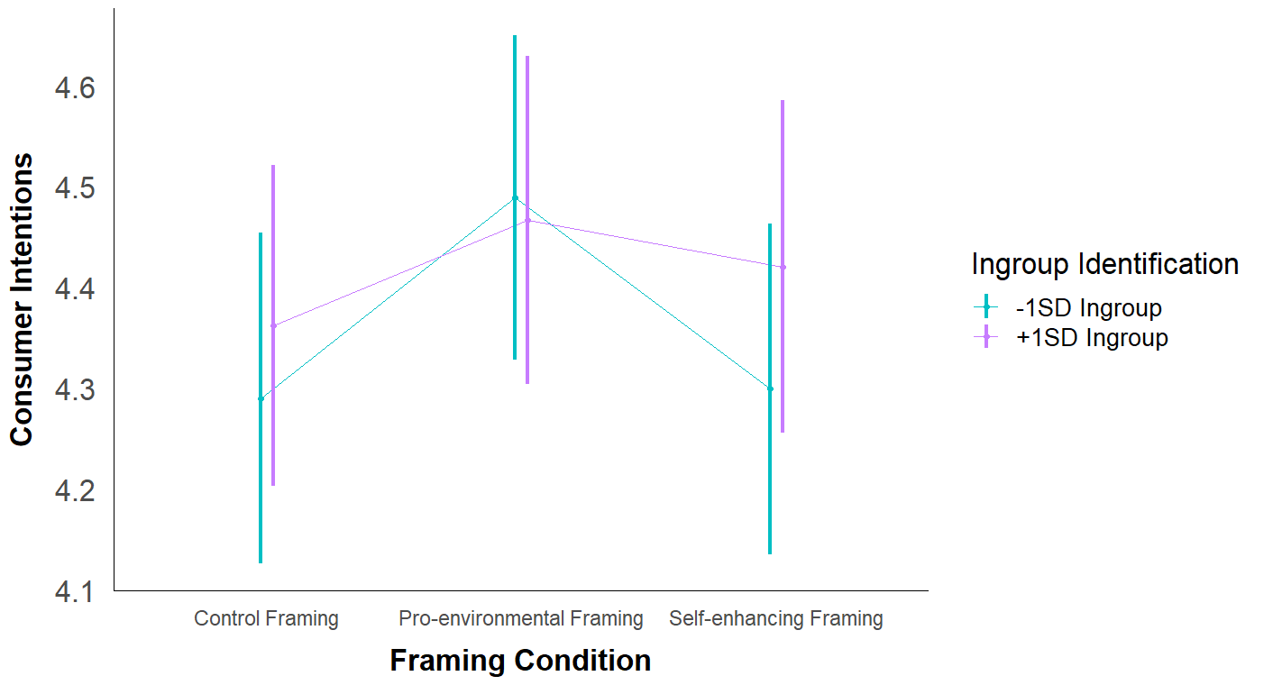

As shown in Table #, unlike what was predicted by hypothesis 5, the effects of each norm-intervention condition were similar for people low and high on in-group identification across most of the norm-intervention conditions. For both people low and high on in-group identification, pro-environmental consumer intentions were slightly, though non-significantly, higher in the convention compared to the control norm condition, and non-significantly lower in the other three norm-intervention conditions.

**Table #**

*Effect of Each Norm-Intervention Condition at Low and High In-group Identification*

| Level of  In-group Identification | Contrast | *EMM*  *Difference* | *95% EMM*  *Difference* | *SE* | *df* | *t* | *p* | *Cohen’s d* |
| --- | --- | --- | --- | --- | --- | --- | --- | --- |
| -1SD In-group Identification | Descriptive vs Control | -0.04 | [-0.34, 0.25] | 0.15 | 1038 | -0.30 | 0.767 | 0.04 |
| Convention vs Control | 0.10 | [-0.18, 0.38] | 0.14 | 1038 | 0.68 | 0.495 | 0.09 |
| Social vs Control | -0.17 | [-0.45, 0.12] | 0.14 | 1038 | -1.15 | 0.249 | 0.16 |
| Moral vs Control | -0.03 | [-0.32, 0.26] | 0.15 | 1038 | -0.21 | 0.831 | 0.03 |
| +1SD In-group Identification | Descriptive vs Control | -0.01 | [-0.30, 0.27] | 0.15 | 1038 | -0.10 | 0.919 | 0.01 |
| Convention vs Control | 0.04 | [-0.26, 0.34] | 0.15 | 1038 | 0.27 | 0.785 | 0.04 |
| Social vs Control | -0.15 | [-0.44, 0.15[ | 0.15 | 1038 | -0.96 | 0.337 | 0.14 |
| Moral vs Control | -0.18 | [-0.47, 0.12] | 0.15 | 1038 | -1.19 | 0.235 | 0.17 |

**Figure #**

*Visualization of the EMMs at Low and High In-group Identification Across Norm Conditions*

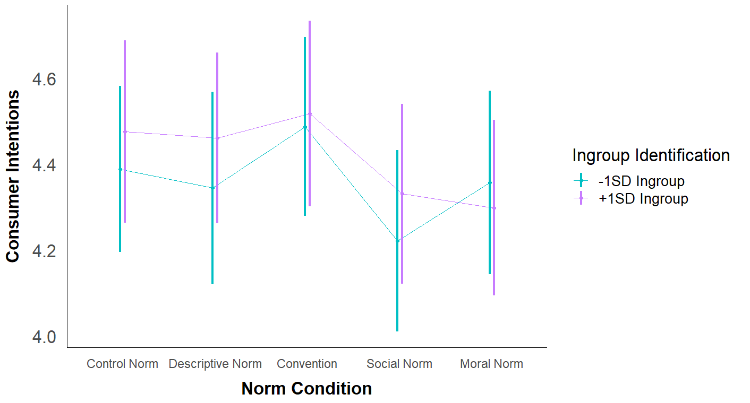

***Exploratory analyses.*** Given the exploratory nature of the last two research questions and the number of multiple comparisons involved, Sidak-adjusted *p*-values and 95%CIs were calculated for these simple effects analyses. To examine the first exploratory research question, I investigated the three-way interaction effect between in-group identification, framing, and norm condition. The EMMs for each condition are given in Table # and visually displayed in Figure #.

**Table #**

*Estimated Marginal Means for Pro-environmental Consumer Intentions at Low and High In-group Identification across Framing and Norm Conditions*

|  | Framing Condition | | | | | |  | |
| --- | --- | --- | --- | --- | --- | --- | --- | --- |
|  | Control | | Pro-environmental | | Self-enhancing | | Per  Norm Condition | |
| Norm Condition | Low | High | Low | High | Low | High | Low | High |
| Control | 4.26 (0.16) | 4.63 (0.18) | 4.62 (0.18) | 4.61 (0.19) | 4.28 (0.17) | 4.19 (0.19) | 4.39 (0.10) | 4.48 (0.11) |
| Descriptive Norm | 4.31 (0.22) | 4.28 (0.18) | 4.38 (0.19) | 4.50 (0.18) | 4.34 (0.18) | 4.60 (0.16) | 4.34 (0.11) | 4.46 (0.10) |
| Convention | 4.60 (0.20) | 4.40 (0.19) | 4.61 (0.17) | 4.46 (0.18) | 4.25 (0.18) | 4.69 (0.21) | 4.49 (0.11) | 4.52 (0.11) |
| Social Norm | 4.15 (0.15) | 4.17 (0.17) | 4.50 (0.19) | 4.35 (0.19) | 4.01 (0.21) | 4.48 (0.19) | 4.22 (0.11) | 4.33 (0.11) |
| Moral Norm | 4.13 (0.20) | 4.33 (0.18) | 4.34 (0.18) | 4.41 (0.18) | 4.61 (0.18) | 4.15 (0.19) | 4.36 (0.11) | 4.30 (0.10) |
| Per Framing Condition | 4.29 (0.08) | 4.36 (0.08) | 4.49 (0.08) | 4.47 (0.08) | 4.30 (0.08) | 4.42 (0.08) |  |  |

*Note.* This table reports EMMs for pro-environmental consumer intentions at low (-1SD) in-group identification and high (+1SD) in-group identification across framing and norm conditions. Standard errors are reported in parentheses.

**Figure #**

*Visualization of the EMMs at Low and High In-group Identification Across Framing and Norm Conditions*

Table # examines the effect of each norm-intervention condition across each framing condition separately for participants low and high on in-group identification. The effects of each norm-intervention condition were the most similar between people high and low on in-group identification in the pro-environmental framing condition and the most dissimilar in the self-enhancing framing condition.

In the pro-environmental framing condition, for both people high and low on in-group identification most of the norm conditions resulted in non-significantly lower pro-environmental consumer intentions compared to the control condition. In the self-enhancing framing condition, for people high on in-group identification, the descriptive, convention, and social norm conditions non-significantly improved pro-environmental consumer intentions, while the moral norm condition had little effect. For people low on in-group identification, the moral norm condition non-significantly improved consumer intentions, the social norm condition non-significantly worsened consumer intentions, and the descriptive norm and convention conditions had little effect.

In the control framing condition, the most notable difference between participants low and high on in-group identification was in the effect of the convention condition. For participants low on in-group identification, the convention non-significantly increased pro-environmental consumer intentions compared to the control norm condition, and non-significantly decreased pro-environmental consumer intentions for people high on in-group identification. The social and moral norm conditions similarly decreased pro-environmental consumer intentions for both groups, though the effect was non-significant.

**Table #**

*Effect of Each Norm-Intervention Condition at Low and High In-group Identification Across Framing Conditions*

| Framing Condition | Level of Values | Contrast of Norm Conditions | *EMM Difference* | *95%CI  EMM Difference* | *SE* | *df* | *t* | *Sidak-adjusted p* | *Cohen’s d* |
| --- | --- | --- | --- | --- | --- | --- | --- | --- | --- |
| Control | -1SD In-group | Descriptive vs Control | 0.04 | [-0.70, 0.79] | 0.27 | 1038 | 0.15 | 1.000 | 0.04 |
| Convention vs Control | 0.33 | [-0.36, 1.03] | 0.25 | 1038 | 1.32 | 0.811 | 0.31 |
| Social vs Control | -0.11 | [-0.71, 0.49] | 0.22 | 1038 | -0.50 | 1.000 | 0.10 |
| Moral vs Control | -0.14 | [-0.84, 0.56] | 0.26 | 1038 | -0.54 | 0.999 | 0.13 |
| +1SD In-group | Descriptive vs Control | -0.36 | [-1.05, 0.34] | 0.26 | 1038 | -1.39 | 0.760 | 0.33 |
| Convention vs Control | -0.23 | [-0.94, 0.48] | 0.26 | 1038 | -0.90 | 0.975 | 0.22 |
| Social vs Control | -0.47 | [-1.15, 0.21] | 0.25 | 1038 | -1.88 | 0.389 | 0.44 |
| Moral vs Control | -0.30 | [-0.98, 0.38] | 0.25 | 1038 | -1.20 | 0.877 | 0.28 |
| PE | -1SD In-group | Descriptive vs Control | -0.23 | [-0.94, 0.47] | 0.26 | 1038 | -0.91 | 0.973 | 0.22 |
| Convention vs Control | 0.00 | [-0.67, 0.66] | 0.24 | 1038 | -0.02 | 1.000 | 0.00 |
| Social vs Control | -0.12 | [-0.83, 0.59] | 0.26 | 1038 | -0.47 | 1.000 | 0.11 |
| Moral vs Control | -0.28 | [-0.97, 0.41] | 0.25 | 1038 | -1.09 | 0.923 | 0.26 |
| +1SD In-group | Descriptive vs Control | -0.11 | [-0.83, 0.62] | 0.26 | 1038 | -0.40 | 1.000 | 0.10 |
| Convention vs Control | -0.14 | [-0.86, 0.58] | 0.26 | 1038 | -0.55 | 0.999 | 0.13 |
| Social vs Control | -0.25 | [-0.99, 0.48] | 0.27 | 1038 | -0.94 | 0.967 | 0.24 |
| Moral vs Control | -0.19 | [-0.90, 0.52] | 0.26 | 1038 | -0.73 | 0.993 | 0.18 |
| SE | -1SD In-group | Descriptive vs Control | 0.06 | [-0.62, 0.74] | 0.25 | 1038 | 0.24 | 1.000 | 0.06 |
| Convention vs Control | -0.03 | [-0.73, 0.66] | 0.25 | 1038 | -0.14 | 1.000 | 0.03 |
| Social vs Control | -0.27 | [-1.02, 0.48] | 0.27 | 1038 | -0.99 | 0.955 | 0.25 |
| Moral vs Control | 0.32 | [-0.36, 1.01] | 0.25 | 1038 | 1.29 | 0.829 | 0.30 |
| +1SD In-group | Descriptive vs Control | 0.42 | [-0.26, 1.09] | 0.25 | 1038 | 1.69 | 0.532 | 0.39 |
| Convention vs Control | 0.50 | [-0.25, 1.26] | 0.28 | 1038 | 1.82 | 0.434 | 0.47 |
| Social vs Control | 0.29 | [-0.44, 1.01] | 0.27 | 1038 | 1.09 | 0.926 | 0.27 |
| Moral vs Control | -0.04 | [-0.76, 0.68] | 0.26 | 1038 | -0.15 | 1.000 | 0.04 |

*Note.* PE = pro-environmental framing, SE = self-enhancing framing, Sidak-adjusted *p*-values and 95%CIs reported

To examine the second exploratory research question, each combination of pro-environmental and self-enhancing framing with each of the norm-intervention conditions was compared to the control framing/control norm condition. The EMMs for each condition were given earlier in the chapter in Table # and shown in Figure #.

The combination of framing and norm conditions with the highest EMMs were the pro-environmental framing/control norm condition (*EMM* = 4.61, *SE* = 0.13) and the pro-environmental framing/convention condition (*EMM* = 4.54, *SE* = 0.12), though neither condition was significantly different from the control framing/control norm condition (*EMM* = 4.45, *SE* = 0.12), (see Table #).

Of the norm conditions that were prefaced by a framing context, the self-enhancing framing/control condition (*EMM* = 4.24, *SE* = 0.13) and the self-enhancing framing/social norm condition (*EMM* = 4.24, *SE* = 0.14) had the lowest EMMs, though neither was significantly different from the control framing/control norm condition.

**Table 11**

*Each Combination of Framing/Norm Condition Compared to the Control Framing/Control Norm Condition*

| Contrast with the  Control Framing/Control Norm Condition | *EM Mean Difference* | *95%CI*  *EM Mean Difference* | *SE* | *df* | *t* | *Sidak-adjusted p* | *Cohen’s d* |
| --- | --- | --- | --- | --- | --- | --- | --- |
| PE + Control Norm | 0.16 | [-0.34, 0.66] | 0.18 | 1038 | 0.91 | 0.989 | 0.15 |
| PE + Descriptive Norm | -0.01 | [-0.51, 0.49] | 0.18 | 1038 | -0.04 | 1.000 | 0.01 |
| PE + Convention | 0.09 | [-0.39, 0.57] | 0.17 | 1038 | 0.51 | 1.000 | 0.08 |
| PE + Social Norm | -0.03 | [-0.54, 0.48] | 0.18 | 1038 | -0.14 | 1.000 | 0.02 |
| PE + Moral Norm | -0.07 | [-0.56, 0.41] | 0.17 | 1038 | -0.42 | 1.000 | 0.07 |
| SE + Control Norm | -0.21 | [-0.71, 0.28] | 0.18 | 1038 | -1.21 | 0.924 | 0.20 |
| SE + Descriptive Norm | 0.02 | [-0.46, 0.51] | 0.17 | 1038 | 0.14 | 1.000 | 0.02 |
| SE + Convention | 0.02 | [-0.48, 0.52] | 0.18 | 1038 | 0.11 | 1.000 | 0.02 |
| SE + Social Norm | -0.20 | [-0.72, 0.31] | 0.18 | 1038 | -1.11 | 0.955 | 0.19 |
| SE + Moral Norm | -0.07 | [-0.57, 0.43] | 0.18 | 1038 | -0.41 | 1.000 | 0.07 |

*Note.* PE = pro-environmental framing, SE = self-enhancing framing, Sidak-adjusted *p*-values and 95%CIs reported

**Logistic Regression Analysis for Consumer Behaviors.**

A logistic regression analysis was performed to analyze the effects of framing condition, norm condition, values, in-group identification, and the interaction effects between these predictors, on consumer behaviors while also controlling for socially desirable responding, interest in clothing, gender, and age. To perform this analysis with the multiply imputed data, the `glm` and `with` functions were used in R. The results were pooled across the individual models using the `micombine.chisquare` function.

**Table #**

*Pooled ANOVA Table for Model Predicting Consumer Behaviors*

|  | *F* | *df1* | *df2* | *p* |
| --- | --- | --- | --- | --- |
| Framing Condition | 5.91 | 2 | 11621.44 | .003 |
| Norm Condition | 0.42 | 4 | 1795.26 | .797 |
| Biospheric Values | 23.76 | 1 | 18929.79 | < .001 |
| Altruistic Values | 2.33 | 1 | 15316.29 | .127 |
| Egoistic Values | 59.35 | 1 | 3235.10 | < .001 |
| Hedonic Values | 0.02 | 1 | 345328.62 | .893 |
| Ingroup Identification | 0.01 | 1 | 8926.29 | .938 |
| Self-deceptive Enhancement | 6.93 | 1 | 1151271.30 | .008 |
| Impression Management | 6.59 | 1 | 25780.06 | .010 |
| Clothing Interest | 0.28 | 1 | 44602.45 | .595 |
| Gender | -0.01 | 1 | 981.23 | 1.000 |
| Age | 3.03 | 1 | 77.38 | .086 |
| Framing x Norm | 0.85 | 8 | 11802.27 | .554 |
| Framing x Biospheric Values | 1.95 | 2 | 31941.74 | .142 |
| Norm x Biospheric Values | 0.87 | 4 | 2157.91 | .478 |
| Framing x Altruistic Values | 5.11 | 2 | 289927.89 | .006 |
| Norm x Altruistic Values | 2.35 | 4 | 10056.48 | 2.35 |
| Framing x Egoistic Values | 2.35 | 2 | 5639.24 | .095 |
| Norm x Egoistic Values | 0.45 | 4 | 1739.09 | .774 |
| Framing x Hedonic Values | 0.32 | 2 | 10144.25 | .729 |
| Norm x Hedonic Values | 0.49 | 4 | 73732.36 | .742 |
| Framing x Ingroup Identification | 0.11 | 2 | 18834.69 | .901 |
| Norm x Ingroup Identification | 0.24 | 4 | 9488.21 | .916 |
| Framing x Norm x Biospheric Values | 0.80 | 8 | 1981.71 | .604 |
| Framing x Norm x Altruistic Values | 1.33 | 8 | 49675.93 | .221 |
| Framing x Norm x Egoistic Values | 0.67 | 8 | 1320.93 | .721 |
| Framing x Norm x Hedonic Values | 0.76 | 8 | 24721.97 | .635 |
| Framing x Norm x Ingroup Identification | 0.42 | 8 | 830.24 | .909 |

***Main effect of framing condition.***

The overall effect of framing condition was significant in the logistic regression model, *F*(2, 11621.44) = 5.91, *p* = .003. This main effect was followed up by simple effects analyses. To aid in interpretability, the scale of the outcome variable was converted from log odds to probabilities when producing the marginal effects tables. Scores on consumer behaviors were coded such that a 1 meant that the participant chose to enroll themselves in the raffle for a $50 gift card to spend on secondhand clothing (the pro-environmental behavior) and a 0 meant that the participant chose to enroll themselves in the raffle for a $50 gift card to spend on new clothing. The estimated marginal probabilities (EMPs) for each level of framing condition are shown in Table #. A higher EMP indicates that the probability of participants choosing the pro-environmental consumer behavior was higher in that particular condition. These EMPs are also visualized in Figure # below.

**Table #**

*Estimated Marginal Probabilities for Consumer Behaviors Across Each Framing Condition*

| Framing Condition | *EM Probability* | *SE* | *95%CI EM*  *Probability* | *Odds Ratio* |
| --- | --- | --- | --- | --- |
| Control Framing | 0.41 | 0.03 | [0.35, 0.47] | 0.69 |
| Pro-environmental Framing | 0.55 | 0.03 | [0.48, 0.61] | 1.22 |
| Self-enhancing Framing | 0.44 | 0.03 | [0.38, 0.50] | 0.79 |

*Note.* Consumer behaviors was coded 0 = new clothing, 1 = secondhand clothing

**Figure #**

*Visualization of the EMPs for Consumer Behaviors Across Each Framing Condition*

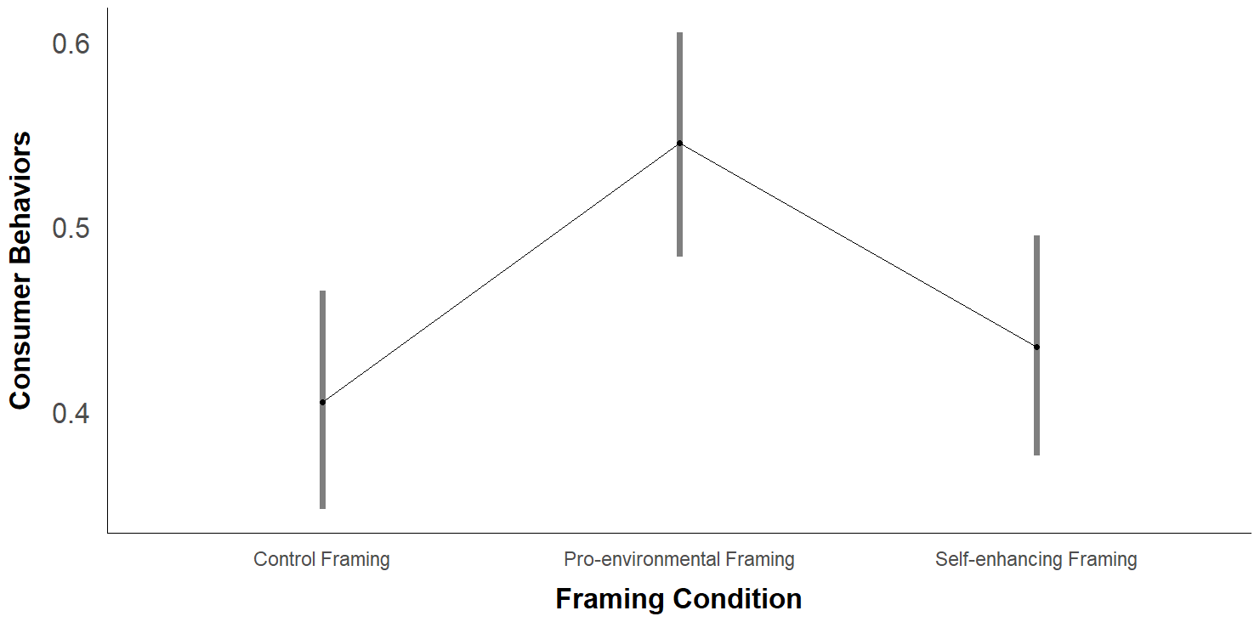

Conditions were compared to one another using the `contrast` function, which, when given the results of a logistic regression model, compares the log-odds of each condition and reports the final difference as an odds ratio. As shown in Table #, the effect of framing condition was very similar to the effect that was observed when using pro-environmental consumer intentions as the outcome variable. The odds of choosing to engage in a pro-environmental consumer behavior were significantly higher in the pro-environmental framing condition compared to the control framing condition, *OR* = 1.76, *z* = 3.25, *p* = .001, and compared to the self-enhancing framing condition, *OR* = 1.56, *z* = 2.52, *p* = .012. This, again, was not the effect that was predicted by hypothesis 1. The odds of choosing the pro-environmental consumer behavior option were non-significantly higher in the self-enhancing framing compared to the control framing condition, *OR* = 1.13, *z* = 0.71, *p* = .479.

**Table #**

*Comparison of Consumer Behaviors Between Framing Conditions*

| Contrast | *Odds Ratio* | *95%CI*  *Odds Ratio* | *SE* | *z* | *p* |
| --- | --- | --- | --- | --- | --- |
| Self-enhancing vs Control | 1.13 | [0.80, 1.59] | 0.20 | 0.71 | .479 |
| Pro-environmental vs Control | 1.76 | [1.25, 2.48] | 0.31 | 3.25 | .001 |
| Pro-environmental vs Self-enhancing | 1.56 | [1.10, 2.20] | 0.27 | 2.52 | .012 |

***Main effect of norm condition.***

The main effect of norm condition was not significant in the overall model, *F*(4, 1795.26) = 0.42, *p* = .797. However, because there was an a priori hypothesis regarding how specific levels of norm condition compare to one another, this effect was still followed up by simple effects analyses. The EMPs for each level of framing condition are shown in Table #. These EMPs are also visualized in Figure # below.

**Table #**

*Estimated Marginal Probabilities for Consumer Behaviors Across Each Norm Condition*

| Framing Condition | *EM Probability* | *SE* | *95%CI EM*  *Probability* | *Odds Ratio* |
| --- | --- | --- | --- | --- |
| Control Norm | 0.42 | 0.04 | [4.29, 4.58] | 0.72 |
| Descriptive Norm | 0.49 | 0.04 | [4.26, 4.55] | 0.96 |
| Convention | 0.46 | 0.04 | [4.36, 4.65] | 0.85 |
| Social Norm | 0.47 | 0.04 | [4.13, 4.42] | 0.89 |
| Moral Norm | 0.48 | 0.04 | [4.18, 4.48] | 0.92 |

**Figure #**

*Visualization of the EMPs for Consumer Behaviors Across Each Framing Condition*

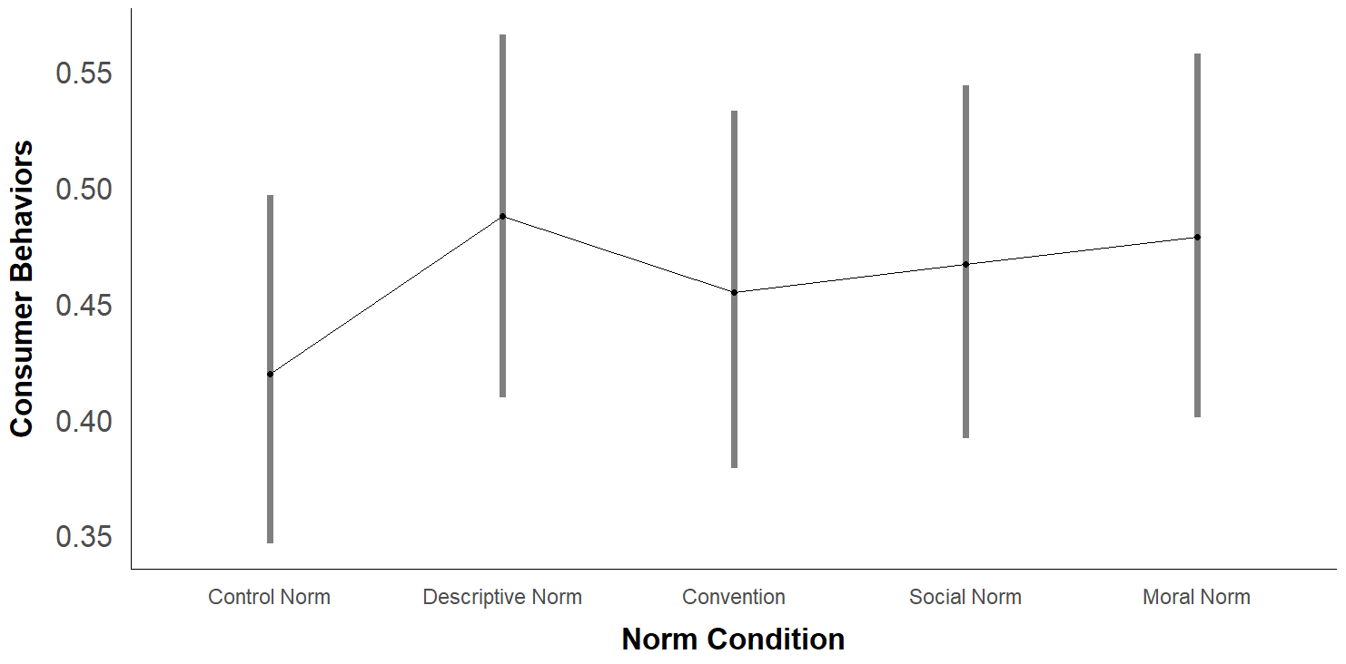

Unlike what was observed in the analysis using consumer intentions as the outcome variable, the probability of choosing the pro-environmental consumer behavior option were highest in the descriptive norm condition and lowest in the control norm condition, though the differences between each norm-intervention condition and the control norm condition were non-significant (see Table #).

**Table #**

*Comparison of Consumer Behaviors Between Norm Conditions*

| Contrast of Norm Conditions | *Odds Ratio* | *95%CI*  *Odds Ratio* | *SE* | *z* | *p* |
| --- | --- | --- | --- | --- | --- |
| Descriptive vs Control | 1.31 | [0.85, 2.04] | 0.30 | 1.22 | 0.224 |
| Convention vs Control | 1.15 | [0.75, 1.78] | 0.26 | 0.65 | 0.518 |
| Social vs Control | 1.21 | [0.79, 1.87] | 0.27 | 0.87 | 0.386 |
| Moral vs Control | 1.27 | [0.82, 1.97] | 0.28 | 1.06 | 0.288 |

***Framing by norm interaction effect.***

The framing by norm interaction effect was not significant in the overall model, *F*(8, 11802.27) = 0.85, *p* = .554. Because there was an a priori hypothesis regarding this two-way interaction, simple effects analyses were still performed to better understand the nature of this interaction effect. The EMPs for each combination of framing and norm condition are shown in Table #. These EMPs are also visualized in Figure #.

**Table #**

*Estimated Marginal Probabilities for Consumer Behaviors Across Norm and Framing Conditions*

|  | Framing Condition | | |  |
| --- | --- | --- | --- | --- |
|  | Control | Pro-environmental | Self-enhancing | Per Norm Condition |
| Norm Condition | *EM Prob* (*SE*) | *EM Prob* (*SE*) | *EM Prob* (*SE*) | *EM Prob* (*SE*) |
| Control | 0.46 (0.07) | 0.44 (0.07) | 0.37 (0.07) | 0.42 (0.04) |
| Descriptive Norm | 0.35 (0.06) | 0.62 (0.07) | 0.49 (0.06) | 0.49 (0.04) |
| Convention | 0.43 (0.07) | 0.53 (0.06) | 0.41 (0.07) | 0.46 (0.04) |
| Social Norm | 0.37 (0.06) | 0.60 (0.07) | 0.44 (0.07) | 0.47 (0.04) |
| Moral Norm | 0.42 (0.08) | 0.54 (0.07) | 0.48 (0.07) | 0.48 (0.04) |
| Per Framing Condition | 0.41 (0.03) | 0.55 (0.03) | 0.44 (0.03) |  |

*Note.* Estimated marginal probabilities from the logistic regression model detailed in Table # (DV = Consumer Behaviors). Standard errors provided in parentheses. Consumer behaviors was coded 0 = new clothing, 1 = secondhand clothing.

**Figure #**

*Visualization of the EMPs for Consumer Behaviors Across Each Framing by Norm Condition*

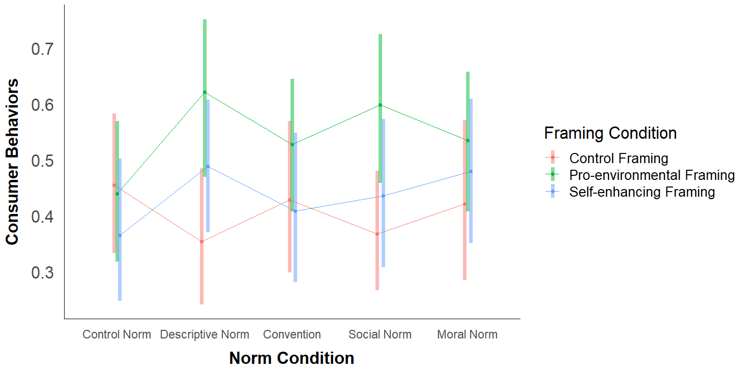

Unlike the results when using consumer intentions as the outcome variable, when predicting consumer behaviors, the pattern of effects for each norm-intervention condition were most similar in the pro-environmental and self-enhancing framing conditions. As shown in Table #, in both the pro-environmental and self-enhancing framing conditions, the odds of choosing the pro-environmental consumer behavior option were higher in each of the norm-intervention conditions compared to the control norm condition, although none of these odds ratios were significant. For both framing conditions, the largest increase in odds appeared to occur for the descriptive norm compared to the control norm condition.

When a control framing was used, the odds of choosing the pro-environmental consumer behavior option were non-significantly lower in each of the norm-intervention conditions compared to the control norm condition.

**Table #**

*Effect of Each Norm Condition on Consumer Behaviors Across Framing Conditions*

| Framing Condition | Contrast of Norm Conditions | *Odds Ratio* | *95%CI  Odds Ratio* | *SE* | *z* | *p* |
| --- | --- | --- | --- | --- | --- | --- |
| Control | Descriptive vs Control | 0.66 | [0.31, 1.38] | 0.25 | -1.11 | 0.266 |
| Convention vs Control | 0.90 | [0.42, 1.93] | 0.35 | -0.28 | 0.782 |
| Social vs Control | 0.69 | [0.35, 1.39] | 0.24 | -1.03 | 0.301 |
| Moral vs Control | 0.87 | [0.40, 1.92] | 0.35 | -0.34 | 0.735 |
| PE | Descriptive vs Control | 2.09 | [0.94, 4.67] | 0.86 | 1.80 | 0.072 |
| Convention vs Control | 1.43 | [0.70, 2.90] | 0.52 | 0.98 | 0.326 |
| Social vs Control | 1.91 | [0.88, 4.11] | 0.75 | 1.64 | 0.100 |
| Moral vs Control | 1.47 | [0.71, 3.05] | 0.55 | 1.03 | 0.305 |
| SE | Descriptive vs Control | 1.66 | [0.79, 3.47] | 0.62 | 1.34 | 0.180 |
| Convention vs Control | 1.20 | [0.54, 2.64] | 0.48 | 0.45 | 0.653 |
| Social vs Control | 1.34 | [0.61, 2.94] | 0.54 | 0.73 | 0.464 |
| Moral vs Control | 1.60 | [0.74, 3.45] | 0.63 | 1.19 | 0.232 |

*Note.* PE = Pro-environmental framing, SE = self-enhancing framing

***Values interaction effects.***

**Biospheric values.** Similarly to the analysis with consumer intentions, biospheric values significantly predicted consumer behaviors, *F*(1, 18929.79) = 23.76, *p* < .001. On average, the odds of choosing the pro-environmental consumer behavior option were significantly higher for people high on biospheric values compared to people low on biospheric values, *OR* = 2.74, *z* = 4.80, *p* < .001, 95%CI[1.82, 4.14].

Unlike the analysis with consumer intentions, there was no significant two-way interaction between biospheric values and norm condition, *F*(4, 2157.91) = 0.87, *p* = .478. There was also still no significant interaction between biospheric values and framing condition, *F*(2, 31941.74) = 1.95, *p* = .142, or three-way interaction between biospheric values, framing condition, and norm condition, *F*(8, 1981.71) = 0.80, *p* = .604. Simple effects analyses were performed to examine the nature of these interaction effects further. EMPs for these contrasts are shown in Table # and are also visually depicted in Figure #.

**Table #**

*Estimated Marginal Probabilities for Consumer Behaviors at Low and High Biospheric Values across Framing and Norm Conditions*

|  | Framing Condition | | | | | |  | |
| --- | --- | --- | --- | --- | --- | --- | --- | --- |
|  | Control | | Pro-environmental | | Self-enhancing | | Per  Norm Condition | |
| Norm Condition | Low | High | Low | High | Low | High | Low | High |
| Control | 0.41 (0.10) | 0.50 (0.10) | 0.31 (0.09) | 0.58 (0.11) | 0.43 (0.12) | 0.30 (0.11) | 0.38 (0.06) | 0.46 (0.07) |
| Descriptive Norm | 0.15 (0.08) | 0.62 (0.12) | 0.38 (0.11) | 0.81 (0.09) | 0.49 (0.11) | 0.49 (0.11) | 0.32 (0.06) | 0.66 (0.07) |
| Convention | 0.28 (0.10) | 0.59 (0.13) | 0.33 (0.10) | 0.72 (0.08) | 0.33 (0.11) | 0.49 (0.13) | 0.31 (0.06) | 0.61 (0.07) |
| Social Norm | 0.26 (0.09) | 0.49 (0.10) | 0.41 (0.09 | 0.76 (0.09) | 0.36 (0.12) | 0.51 (0.14) | 0.34 (0.06) | 0.59 (0.07) |
| Moral Norm | 0.44 (0.18) | 0.40 (0.12) | 0.37 (0.10) | 0.69 (0.09) | 0.24 (0.11) | 0.73 (0.11) | 0.35 (0.08) | 0.61 (0.07) |
| Per Framing Condition | 0.30 (0.05) | 0.52 (0.05) | 0.36 (0.04) | 0.72 (0.04) | 0.37 (0.05) | 0.51 (0.06) |  |  |

*Note.* This table reports EMPs for consumer behaviors (0 = new clothing, 1 = secondhand clothing) at low (-1SD) biospheric values and high (+1SD) biospheric values across framing and norm conditions. Standard errors are reported in parentheses.

**Figure #**

*Visualization of the EMPs at Low and High Biospheric Values Across Framing and Norm Conditions*

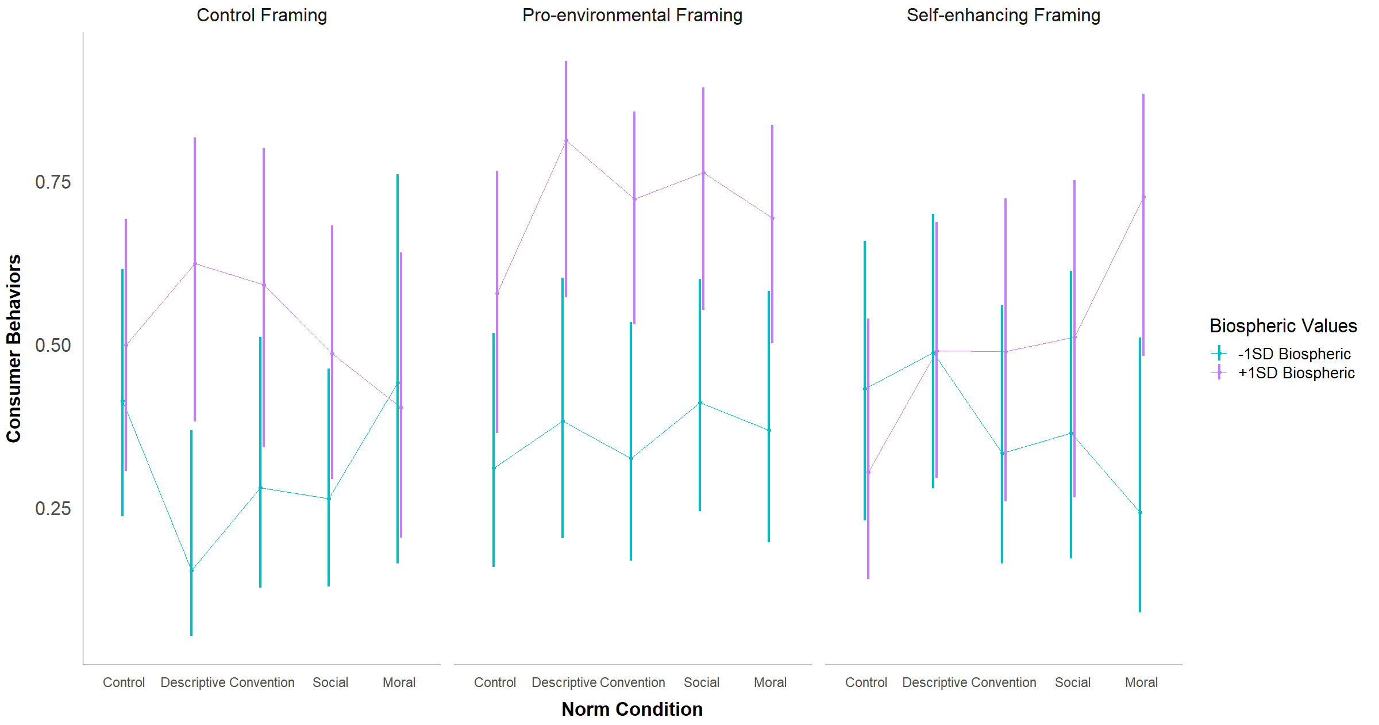

Similarly to the consumer intentions analysis, participants high on biospheric values had significantly higher odds of choosing the pro-environmental consumer behavior option compared to participants low on biospheric values in the control and pro-environmental framing conditions, *p*s < .015, but non-significantly higher in the self-enhancing framing condition (see Table #).

**Table #**

*Comparison of Consumer Behaviors Between People Low and High on Biospheric Values across Framing Conditions*

| Contrast | *Odds Ratio* | *95%CI*  *Odds Ratio* | *SE* | *z* | *p* |
| --- | --- | --- | --- | --- | --- |
| C framing: High Bio - Low Bio | 2.55 | [1.20, 5.40] | 0.98 | 2.44 | 0.015 |
| PE framing: High Bio - Low Bio | 4.60 | [2.42, 8.72] | 1.50 | 4.67 | <.001 |
| SE framing: High Bio - Low Bio | 1.76 | [0.84, 3.68] | 0.66 | 1.50 | 0.133 |

*Note.* C = control, PE = pro-environmental, SE = self-enhancing

Similarly to the consumer intentions analysis, participants high on biospheric values also had significantly higher odds of choosing the pro-environmental consumer behavior option in the descriptive, convention, and social norm conditions, all *p*s < .021 (see Table #). Unlike the analysis with consumer intentions, though, participants high on biospheric values also had significantly higher odds of choosing the pro-environmental consumer behavior option in the moral norm condition, *p* = .040, and the two groups did not differ significantly in the control norm condition.

**Table #**

*Comparison of Consumer Behaviors Between People Low and High on Biospheric Values across Norm Conditions*

| Contrast | *Odds Ratio* | *95%CI*  *Odds Ratio* | *SE* | *z* | *p* |
| --- | --- | --- | --- | --- | --- |
| Control norm: High Bio - Low Bio | 1.35 | [0.60, 3.05] | 0.56 | 0.73 | 0.467 |
| Descriptive: High Bio - Low Bio | 4.01 | [1.53, 10.53] | 1.98 | 2.82 | 0.005 |
| Convention: High Bio - Low Bio | 3.37 | [1.38, 8.23] | 1.53 | 2.67 | 0.008 |
| Social norm: High Bio - Low Bio | 2.81 | [1.17, 6.77] | 1.26 | 2.31 | 0.021 |
| Moral norm: High Bio - Low Bio | 3.02 | [1.05, 8.64] | 1.62 | 2.06 | 0.040 |

The nature of the three-way interaction between biospheric values, framing condition, and norm condition was very dissimilar when predicting consumer behaviors than when predicting consumer intentions (see Table #). The most similar pattern of effects was observed in the control framing condition. The only differences were that, for people low on biospheric values in the control framing condition, the social norm condition non-significantly decreased people’s odds of choosing the pro-environmental behavior option, whereas it non-significantly increased people’s pro-environmental consumer intentions. Additionally, for people high on biospheric values, the descriptive norm condition non-significantly increased people’s odds of choosing the pro-environmental behavior option, whereas it non-significantly decreased people’s pro-environmental consumer intentions.

In the pro-environmental framing condition, the effects of each norm-intervention condition on people low on biospheric values were in the opposite direction as they were in the consumer intentions analysis. When predicting consumer behaviors, exposure to every norm-intervention condition in the pro-environmental framing condition non-significantly increased people’s odds of choosing the pro-environmental consumer behavior option, whereas they non-significantly decreased people’s pro-environmental consumer intentions. For people high on biospheric values, each norm-intervention condition non-significantly increased the odds of people choosing the pro-environmental consumer behavior option.

The pattern of the effects of each norm-intervention condition in the self-enhancing framing condition were also very dissimilar to what was observed in the consumer intentions analysis. For participants low on biospheric values, exposure to every norm-intervention condition non-significantly decreased people’s odds of choosing the pro-environmental consumer behavior option, whereas they non-significantly increased people’s pro-environmental consumer intentions. For participants high on biospheric values, the odds of choosing the pro-environmental consumer behavior option was higher in every norm-intervention condition compared to the control norm condition. This difference was significant in the moral norm compared to the control norm condition, *p* = .014, but non-significant in the other three conditions. In the consumer intentions analysis, pro-environmental consumer intentions were non-significantly lower in the social and moral norm conditions, and unaffected by the descriptive norm and convention conditions.

**Table #**

*Effect of Each Norm Condition at Low and High Biospheric Values Across Framing Conditions*

| Framing Condition | Level of Values | Contrast of Norm Conditions | *Odds Ratio* | *95%CI  Odds Ratio* | *SE* | *z* | *p* |
| --- | --- | --- | --- | --- | --- | --- | --- |
| Control | -1SD Biospheric | Descriptive vs Control | 0.26 | [0.06, 1.07] | 0.19 | -1.86 | 0.063 |
| Convention vs Control | 0.55 | [0.15, 2.00] | 0.36 | -0.90 | 0.367 |
| Social vs Control | 0.51 | [0.15, 1.71] | 0.31 | -1.09 | 0.274 |
| Moral vs Control | 1.12 | [0.23, 5.52] | 0.91 | 0.14 | 0.888 |
| +1SD Biospheric | Descriptive vs Control | 1.67 | [0.47, 5.94] | 1.08 | 0.79 | 0.431 |
| Convention vs Control | 1.45 | [0.39, 5.36] | 0.97 | 0.56 | 0.575 |
| Social vs Control | 0.95 | [0.30, 3.05] | 0.56 | -0.09 | 0.930 |
| Moral vs Control | 0.68 | [0.19, 2.40] | 0.44 | -0.60 | 0.547 |
| PE | -1SD Biospheric | Descriptive vs Control | 1.38 | [0.40, 4.78] | 0.87 | 0.50 | 0.614 |
| Convention vs Control | 1.07 | [0.31, 3.65] | 0.67 | 0.11 | 0.913 |
| Social vs Control | 1.55 | [0.49, 4.91] | 0.91 | 0.74 | 0.460 |
| Moral vs Control | 1.30 | [0.38, 4.42] | 0.81 | 0.42 | 0.677 |
| +1SD Biospheric | Descriptive vs Control | 3.17 | [0.73, 13.71] | 2.37 | 1.55 | 0.122 |
| Convention vs Control | 1.90 | [0.57, 6.34] | 1.17 | 1.05 | 0.295 |
| Social vs Control | 2.35 | [0.64, 8.57] | 1.55 | 1.29 | 0.196 |
| Moral vs Control | 1.66 | [0.50, 5.45] | 1.01 | 0.83 | 0.406 |
| SE | -1SD Biospheric | Descriptive vs Control | 1.25 | [0.34, 4.57] | 0.83 | 0.34 | 0.735 |
| Convention vs Control | 0.66 | [0.18, 2.47] | 0.44 | -0.62 | 0.534 |
| Social vs Control | 0.75 | [0.19, 3.00] | 0.53 | -0.40 | 0.689 |
| Moral vs Control | 0.42 | [0.09, 1.89] | 0.32 | -1.13 | 0.259 |
| +1SD Biospheric | Descriptive vs Control | 2.19 | [0.61, 7.96] | 1.44 | 1.20 | 0.232 |
| Convention vs Control | 2.19 | [0.53, 8.97] | 1.58 | 1.09 | 0.277 |
| Social vs Control | 2.39 | [0.56, 10.14] | 1.76 | 1.18 | 0.239 |
| Moral vs Control | 6.06 | [1.44, 25.46] | 4.44 | 2.46 | 0.014 |

*Note.* PE = pro-environmental, SE = self-enhancing

**Altruistic values.** In the overall model, altruistic values did not significantly predict consumer behaviors, *F*(1, 15316.29) = 2.33, *p* = .127. The odds of choosing the pro-environmental consumer behavior option were not significantly higher for people high on altruistic values compared to people low on altruistic values, *OR* = 1.44, *z* = 1.53, *p* = .127, 95%CI[0.90, 2.29].

Additionally, there was a significant two-way interaction between altruistic values and framing condition, *F*(2, 289927.89) = 5.11, *p* = .006, but no significant between altruistic values and norm condition, *F*(4, 10056.48) = 2.35, *p* = .052. The three-way interaction between altruistic values, framing condition, and norm condition was also non-significant, *F*(8, 49675.93) = 1.33, *p* = .221. Simple effects analyses were performed to examine the nature of these interaction effects further. EMPs for these contrasts are shown in Table # and are also visually depicted in Figure #.

**Table #**

*Estimated Marginal Probabilities for Consumer Behaviors at Low and High Altruistic Values across Framing and Norm Conditions*

|  | Framing Condition | | | | | |  | |
| --- | --- | --- | --- | --- | --- | --- | --- | --- |
|  | Control | | Pro-environmental | | Self-enhancing | | Per  Norm Condition | |
| Norm Condition | Low | High | Low | High | Low | High | Low | High |
| Control | 0.36 (0.11) | 0.55 (0.10) | 0.61 (0.12) | 0.28 (0.11) | 0.13 (0.08) | 0.69 (0.13) | 0.34 (0.07) | 0.50 (0.08) |
| Descriptive Norm | 0.54 (0.12) | 0.21 (0.10) | 0.84 (0.10) | 0.33 (0.11) | 0.41 (0.10) | 0.57 (0.11) | 0.62 (0.08) | 0.36 (0.07) |
| Convention | 0.41 (0.12) | 0.44 (0.12) | 0.46 (0.12) | 0.60 (0.11) | 0.23 (0.10) | 0.61 (0.12) | 0.36 (0.07) | 0.55 (0.07) |
| Social Norm | 0.36 (0.11) | 0.37 (0.10) | 0.52 (0.13) | 0.67 (0.11) | 0.29 (0.14) | 0.59 (0.14) | 0.39 (0.08) | 0.55 (0.07) |
| Moral Norm | 0.25 (0.09) | 0.62 (0.15) | 0.50 (0.10) | 0.57 (0.11) | 0.42 (0.11) | 0.54 (0.12) | 0.38 (0.06) | 0.58 (0.08) |
| Per Framing Condition | 0.38 (0.05) | 0.43 (0.06) | 0.60 (0.06) | 0.49 (0.06) | 0.28 (0.05) | 0.60 (0.06) |  |  |

*Note.* This table reports EMPs for consumer behaviors (0 = new clothing, 1 = secondhand clothing) at low (-1SD) biospheric values and high (+1SD) biospheric values across framing and norm conditions. Standard errors are reported in parentheses.

**Figure #**

*Visualization of the EMPs at Low and High Altruistic Values Across Framing and Norm Conditions*

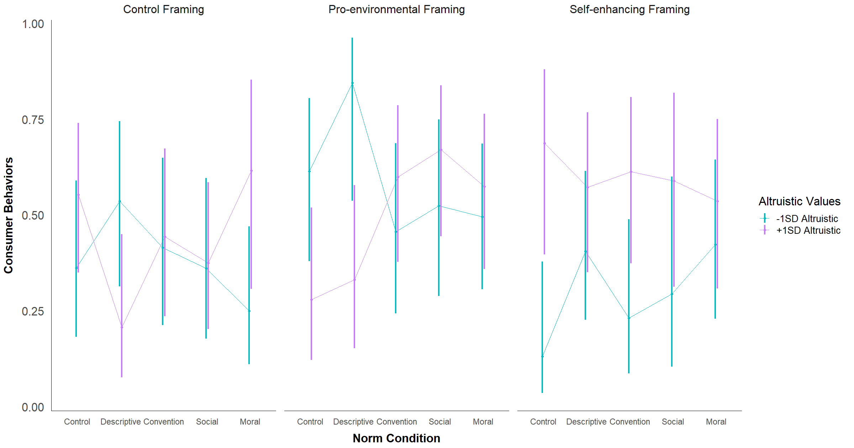

The pattern of the effect of framing by altruistic values interaction effect was very similar to what was observed in the analysis predicting consumer intentions. In the self-enhancing framing condition, the odds of choosing the pro-environmental consumer option were significantly higher for people high on altruistic values compared to people low on altruistic values, and non-significantly higher in the control framing condition (see Table #). In the pro-environmental framing condition, the odds of choosing the pro-environmental consumer option were non-significantly lower for people high versus low on altruistic values.

**Table #**

*Comparison of Consumer Behaviors Between People Low and High on Altruistic Values across Framing Conditions*

| Contrast | *Odds Ratio* | *95%CI*  *Odds Ratio* | *SE* | *z* | *p* |
| --- | --- | --- | --- | --- | --- |
| C framing: High Alt - Low Alt | 1.23 | [0.59, 2.59] | 0.47 | 0.55 | 0.580 |
| PE framing: High Alt - Low Alt | 0.63 | [0.29, 1.38] | 0.25 | -1.16 | 0.248 |
| SE framing: High Alt - Low Alt | 3.81 | [1.63, 8.92] | 1.65 | 3.08 | 0.002 |

*Note.* C = control, PE = pro-environmental, SE = self-enhancing

The pattern of the norm by altruistic values interaction effect was also very similar to what was described for the consumer intentions analysis. The only difference was in the effect of the convention condition. In the convention condition, the odds of choosing the pro-environmental consumer behavior option were non-significantly higher among people high versus low on altruistic values, whereas there was little difference in pro-environmental consumer intentions between these two groups.

**Table #**

*Comparison of Consumer Behaviors Between People Low and High on Altruistic Values across Norm Conditions*

| Contrast | *Odds Ratio* | *95%CI*  *Odds Ratio* | *SE* | *z* | *p* |
| --- | --- | --- | --- | --- | --- |
| Control norm: High Alt - Low Alt | 1.97 | [0.67, 5.84] | 1.09 | 1.23 | 0.218 |
| Descriptive: High Alt - Low Alt | 0.34 | [0.12, 1.01] | 0.19 | -1.93 | 0.053 |
| Convention: High Alt - Low Alt | 2.19 | [0.84, 5.69] | 1.07 | 1.61 | 0.107 |
| Social norm: High Alt - Low Alt | 1.89 | [0.67, 5.32] | 1.00 | 1.21 | 0.228 |
| Moral norm: High Alt - Low Alt | 2.18 | [0.84, 5.66] | 1.06 | 1.61 | 0.108 |

The pattern of the effect of each norm-intervention condition was most similar to that observed in the consumer intentions analysis for the control framing condition (see Table #). The only notable difference was that, for people low on altruistic values, the social norm condition had no effect on people’s odds of choosing the pro-environmental consumer behavior option, whereas it non-significantly decreased people’s pro-environmental consumer intentions.

In the pro-environmental framing condition, for people low on altruistic values, the descriptive norm condition non-significantly improved people’s odds of choosing the pro-environmental consumer behavior option, whereas it non-significantly decreased these individuals’ pro-environmental consumer intentions. For people high on altruistic values, exposure to every norm-intervention condition improved the odds of people choosing the pro-environmental consumer behavior option. This improvement was significant in the social norm condition, *p* = .018, and non-significant in the other three norm conditions. This was opposite the effect seen in the consumer intentions analysis in which, for people high on altruistic values, exposure to every norm condition in the pro-environmental framing condition non-significantly decreased pro-environmental consumer intentions.

The pattern of effects of each norm-intervention condition were also similar to what was observed in the consumer intentions analysis for the self-enhancing condition. The only notable differences were that, for people low on altruistic values, the moral norm condition non-significantly improved people’s odds of choosing the pro-environmental consumer behavior option, whereas it non-significantly decreased these individuals’ pro-environmental consumer intentions. Additionally, for people high on altruistic values, the convention and moral norm conditions had opposite effects as what was observed in the consumer intentions analysis. Both the convention and moral norm conditions non-significantly decreased these individuals’ odds of choosing the pro-environmental consumer behavior option.

**Table #**

*Effect of Each Norm Condition at Low and High Altruistic Values Across Framing Conditions*

| Framing Condition | Level of Values | Contrast of Norm Conditions | *Odds Ratio* | *95%CI  Odds Ratio* | *SE* | *z* | *p* |
| --- | --- | --- | --- | --- | --- | --- | --- |
| Control | -1SD Altruistic | Descriptive vs Control | 2.04 | [0.55, 7.56] | 1.36 | 1.06 | 0.287 |
| Convention vs Control | 1.25 | [0.33, 4.75] | 0.85 | 0.33 | 0.744 |
| Social vs Control | 1.00 | [0.26, 3.81] | 0.68 | -0.01 | 0.995 |
| Moral vs Control | 0.59 | [0.15, 2.26] | 0.40 | -0.77 | 0.439 |
| +1SD Altruistic | Descriptive vs Control | 0.21 | [0.05, 0.86] | 0.15 | -2.17 | 0.030 |
| Convention vs Control | 0.64 | [0.18, 2.27] | 0.41 | -0.68 | 0.495 |
| Social vs Control | 0.48 | [0.15, 1.61] | 0.30 | -1.18 | 0.238 |
| Moral vs Control | 1.30 | [0.29, 5.82] | 0.99 | 0.34 | 0.734 |
| PE | -1SD Altruistic | Descriptive vs Control | 3.41 | [0.56, 20.78] | 3.14 | 1.33 | 0.183 |
| Convention vs Control | 0.53 | [0.14, 2.04] | 0.36 | -0.93 | 0.355 |
| Social vs Control | 0.69 | [0.17, 2.74] | 0.49 | -0.52 | 0.600 |
| Moral vs Control | 0.62 | [0.18, 2.15] | 0.39 | -0.76 | 0.449 |
| +1SD Altruistic | Descriptive vs Control | 1.28 | [0.30, 5.41] | 0.94 | 0.34 | 0.736 |
| Convention vs Control | 3.85 | [0.99, 14.96] | 2.67 | 1.95 | 0.051 |
| Social vs Control | 5.25 | [1.32, 20.84] | 3.69 | 2.36 | 0.018 |
| Moral vs Control | 3.48 | [0.91, 13.32] | 2.38 | 1.82 | 0.069 |
| SE | -1SD Altruistic | Descriptive vs Control | 4.51 | [0.88, 23.07] | 3.76 | 1.81 | 0.071 |
| Convention vs Control | 1.99 | [0.33, 12.13] | 1.84 | 0.75 | 0.455 |
| Social vs Control | 2.75 | [0.42, 18.20] | 2.65 | 1.05 | 0.293 |
| Moral vs Control | 4.84 | [0.92, 25.47] | 4.10 | 1.86 | 0.062 |
| +1SD Altruistic | Descriptive vs Control | 0.61 | [0.14, 2.74] | 0.47 | -0.65 | 0.518 |
| Convention vs Control | 0.72 | [0.16, 3.35] | 0.57 | -0.42 | 0.678 |
| Social vs Control | 0.65 | [0.13, 3.41] | 0.55 | -0.50 | 0.614 |
| Moral vs Control | 0.53 | [0.11, 2.43] | 0.41 | -0.82 | 0.412 |

*Note.* PE = pro-environmental, SE = self-enhancing

**Egoistic values.** In the overall model, egoistic values significantly predicted consumer behaviors, *F*(1, 3235.10) = 59.35, *p* < .001. On average, the odds of choosing the pro-environmental consumer behavior option were significantly lower for people high on egoistic values compared to people low on egoistic values, *OR* = 0.26, *z* = -7.29, *p* < .001, 95%CI[0.18, 0.38].

There was no significant two-way interaction between egoistic values and framing condition, *F*(2, 5639.24) = 2.35, *p* = .095, or between egoistic values and norm condition, *F*(4, 1739.09) = 0.45, *p* = .774. The three-way interaction between egoistic values, framing condition, and norm condition was also non-significant, *F*(8, 1320.93) = 0.67, *p* = .721. Simple effects analyses were performed to examine the nature of these interaction effects further. EMPs for these contrasts are shown in Table # and are also visually depicted in Figure #.

**Table #**

*Estimated Marginal Probabilities for Consumer Behaviors at Low and High Egoistic Values across Framing and Norm Conditions*

|  | Framing Condition | | | | | |  | |
| --- | --- | --- | --- | --- | --- | --- | --- | --- |
|  | Control | | Pro-environmental | | Self-enhancing | | Per  Norm Condition | |
| Norm Condition | Low | High | Low | High | Low | High | Low | High |
| Control | 0.49 (0.08) | 0.42 (0.10) | 0.60 (0.09) | 0.29 (0.08) | 0.65 (0.11) | 0.15 (0.07) | 0.58 (0.06) | 0.27 (0.05) |
| Descriptive Norm | 0.36 (0.10) | 0.35 (0.09) | 0.78 (0.10) | 0.43 (0.09) | 0.73 (0.09) | 0.25 (0.09) | 0.64 (0.07) | 0.34 (0.06) |
| Convention | 0.63 (0.10) | 0.25 (0.08) | 0.71 (0.09) | 0.34 (0.10) | 0.59 (0.10) | 0.25 (0.08) | 0.64 (0.05) | 0.28 (0.05) |
| Social Norm | 0.42 (0.08) | 0.32 (0.08) | 0.75 (0.09) | 0.43 (0.11) | 0.57 (0.11) | 0.31 (0.09) | 0.59 (0.06) | 0.35 (0.05) |
| Moral Norm | 0.63 (0.12) | 0.24 (0.09) | 0.72 (0.09) | 0.34 (0.09) | 0.67 (0.10) | 0.29 (0.09) | 0.67 (0.06) | 0.29 (0.05) |
| Per Framing Condition | 0.51 (0.05) | 0.31 (0.04) | 0.71 (0.04) | 0.37 (0.04) | 0.65 (0.05) | 0.25 (0.04) |  |  |

*Note.* This table reports EMPs for consumer behaviors (0 = new clothing, 1 = secondhand clothing) at low (-1SD) biospheric values and high (+1SD) biospheric values across framing and norm conditions. Standard errors are reported in parentheses.

**Figure #**

*Visualization of the EMPs at Low and High Egoistic Values Across Framing and Norm Conditions*

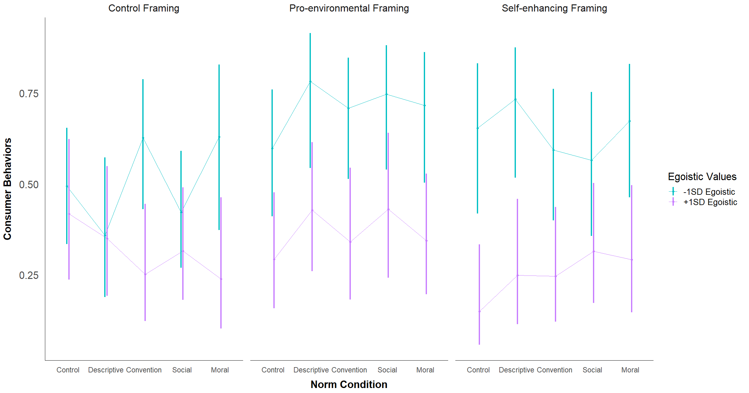

The same pattern of two-way interaction effects involving egoistic values as were described for the consumer intentions analysis were observed in the consumer behaviors results. The odds of choosing the pro-environmental consumer behavior option were significantly lower among people high versus low on egoistic values across all framing conditions, *p*s < .006 (see Table #). Similarly, the odds of choosing the pro-environmental consumer behavior option were also significantly lower among people high versus low on egoistic values across all norm conditions, *p*s < .009.

**Table #**

*Comparison of Consumer Behaviors Between People Low and High on Egoistic Values across Framing Conditions*

| Contrast | *Odds Ratio* | *95%CI*  *Odds Ratio* | *SE* | *z* | *p* |
| --- | --- | --- | --- | --- | --- |
| C framing: High Ego - Low Ego | 0.44 | [0.25, 0.79] | 0.13 | -2.77 | 0.006 |
| PE framing: High Ego - Low Ego | 0.23 | [0.13, 0.42] | 0.07 | -4.79 | <.001 |
| SE framing: High Ego - Low Ego | 0.18 | [0.09, 0.34] | 0.06 | -5.30 | <.001 |

*Note.* C = control, PE = pro-environmental, SE = self-enhancing

**Table #**

*Comparison of Consumer Behaviors Between People Low and High on Egoistic Values across Norm Conditions*

| Contrast | *Odds Ratio* | *95%CI*  *Odds Ratio* | *SE* | *z* | *p* |
| --- | --- | --- | --- | --- | --- |
| Control norm: High Ego - Low Ego | 0.27 | [0.12, 0.58] | 0.10 | -3.36 | 0.001 |
| Descriptive: High Ego - Low Ego | 0.29 | [0.12, 0.67] | 0.12 | -2.88 | 0.004 |
| Convention: High Ego - Low Ego | 0.21 | [0.10, 0.44] | 0.08 | -4.15 | <.001 |
| Social norm: High Ego - Low Ego | 0.38 | [0.19, 0.79] | 0.14 | -2.62 | 0.009 |
| Moral norm: High Ego - Low Ego | 0.20 | [0.09, 0.46] | 0.08 | -3.80 | <.001 |

As shown in Table #, the pattern of the three-way interaction effect between egoistic values, framing condition, and norm condition was very similar to what was observed in the consumer intentions analysis in the control framing and self-enhancing framing conditions. In the control framing condition, the only difference was that, for participants low on egoistic values, the moral norm condition non-significantly improved people’s odds of choosing the pro-environmental consumer behavior option, whereas it non-significantly decreased these individuals’ pro-environmental intentions. In the self-enhancing framing condition, the only difference was observed in the direction of the effect of the convention condition on low egoistic individuals. The convention non-significantly decreased these individuals’ odds of choosing the pro-environmental consumer option, whereas it non-significantly increased their pro-environmental consumer intentions.

In the pro-environmental framing condition, the effects of each norm-intervention condition on low egoistic individuals were opposite of what was seen in the consumer intentions analysis. For these individuals, exposure to each norm-intervention condition non-significantly improved their odds of choosing the pro-environmental consumer behavior option, whereas they decreased these individuals’ pro-environmental consumer intentions. For participants high on egoistic values, the pattern of the effect of each norm-intervention condition stayed largely the same.

**Table #**

*Effect of Each Norm Condition at Low and High Egoistic Values Across Framing Conditions*

| Framing Condition | Level of Values | Contrast of Norm Conditions | *Odds Ratio* | *95%CI  Odds Ratio* | *SE* | *z* | *p* |
| --- | --- | --- | --- | --- | --- | --- | --- |
| Control | -1SD Egoistic | Descriptive vs Control | 0.57 | [0.19, 1.71] | 0.32 | -1.00 | 0.319 |
| Convention vs Control | 1.72 | [0.61, 4.83] | 0.91 | 1.03 | 0.303 |
| Social vs Control | 0.75 | [0.29, 1.91] | 0.36 | -0.61 | 0.544 |
| Moral vs Control | 1.74 | [0.50, 6.03] | 1.10 | 0.87 | 0.382 |
| +1SD Egoistic | Descriptive vs Control | 0.75 | [0.23, 2.41] | 0.45 | -0.48 | 0.630 |
| Convention vs Control | 0.47 | [0.14, 1.57] | 0.29 | -1.23 | 0.218 |
| Social vs Control | 0.64 | [0.21, 1.95] | 0.36 | -0.78 | 0.436 |
| Moral vs Control | 0.44 | [0.12, 1.65] | 0.30 | -1.22 | 0.223 |
| PE | -1SD Egoistic | Descriptive vs Control | 2.42 | [0.64, 9.16] | 1.64 | 1.30 | 0.194 |
| Convention vs Control | 1.63 | [0.53, 5.00] | 0.93 | 0.86 | 0.390 |
| Social vs Control | 1.99 | [0.61, 6.55] | 1.21 | 1.13 | 0.257 |
| Moral vs Control | 1.70 | [0.52, 5.53] | 1.02 | 0.88 | 0.378 |
| +1SD Egoistic | Descriptive vs Control | 1.81 | [0.60, 5.41] | 1.01 | 1.06 | 0.290 |
| Convention vs Control | 1.25 | [0.39, 3.95] | 0.73 | 0.37 | 0.708 |
| Social vs Control | 1.82 | [0.57, 5.87] | 1.09 | 1.01 | 0.314 |
| Moral vs Control | 1.26 | [0.42, 3.78] | 0.71 | 0.42 | 0.674 |
| SE | -1SD Egoistic | Descriptive vs Control | 1.45 | [0.38, 5.60] | 1.00 | 0.54 | 0.586 |
| Convention vs Control | 0.77 | [0.22, 2.66] | 0.49 | -0.41 | 0.682 |
| Social vs Control | 0.69 | [0.19, 2.49] | 0.45 | -0.57 | 0.569 |
| Moral vs Control | 1.09 | [0.30, 3.98] | 0.72 | 0.13 | 0.897 |
| +1SD Egoistic | Descriptive vs Control | 1.89 | [0.46, 7.67] | 1.35 | 0.89 | 0.374 |
| Convention vs Control | 1.86 | [0.48, 7.20] | 1.29 | 0.90 | 0.367 |
| Social vs Control | 2.61 | [0.70, 9.71] | 1.75 | 1.44 | 0.151 |
| Moral vs Control | 2.34 | [0.60, 9.18] | 1.63 | 1.22 | 0.221 |

*Note.* PE = pro-environmental, SE = self-enhancing

**Hedonic values.** In the overall model, hedonic values did not significantly predict consumer behaviors, *F*(1, 345328.62) = 0.02, *p* = .893. There was no significant difference in the odds of choosing the pro-environmental consumer behavior option between people high and low on hedonic values, *OR* = 1.01, *z* = 0.07, *p* = .948, 95%CI[0.70, 1.47].

There was no significant two-way interaction between hedonic values and framing condition, *F*(2, 10144.25) = 0.32, *p* = .729, or between hedonic values and norm condition, *F*(4, 73732.36) = 0.49, *p* = .742. The three-way interaction between hedonic values, framing condition, and norm condition was also non-significant, *F*(8, 24721.97) = 0.76, *p* = .635. Simple effects analyses were performed to examine the nature of these interaction effects further. EMPs for these contrasts are shown in Table # and are also visually depicted in Figure #.

**Table #**

*Estimated Marginal Probabilities for Consumer Behaviors at Low and High Hedonic Values across Framing and Norm Conditions*

|  | Framing Condition | | | | | |  | |
| --- | --- | --- | --- | --- | --- | --- | --- | --- |
|  | Control | | Pro-environmental | | Self-enhancing | | Per  Norm Condition | |
| Norm Condition | Low | High | Low | High | Low | High | Low | High |
| Control | 0.39 (0.11) | 0.53 (0.09) | 0.44 (0.12) | 0.44 (0.10) | 0.32 (0.12) | 0.42 (0.11) | 0.38 (0.07) | 0.46 (0.06) |
| Descriptive Norm | 0.33 (0.10) | 0.37 (0.11) | 0.67 (0.10) | 0.57 (0.13) | 0.37 (0.11) | 0.61 (0.11) | 0.46 (0.07) | 0.52 (0.07) |
| Convention | 0.34 (0.12) | 0.53 (0.10) | 0.53 (0.11) | 0.52 (0.11) | 0.50 (0.10) | 0.32 (0.11) | 0.45 (0.07) | 0.46 (0.06) |
| Social Norm | 0.42 (0.10) | 0.32 (0.08) | 0.57 (0.11) | 0.63 (0.11) | 0.54 (0.13) | 0.33 (0.11) | 0.51 (0.07) | 0.42 (0.06) |
| Moral Norm | 0.43 (0.13) | 0.41 (0.12) | 0.50 (0.10) | 0.57 (0.11) | 0.57 (0.09) | 0.39 (0.10) | 0.50 (0.06) | 0.46 (0.06) |
| Per Framing Condition | 0.38 (0.05) | 0.43 (0.05) | 0.54 (0.05) | 0.55 (0.05) | 0.46 (0.05) | 0.41 (0.05) |  |  |

*Note.* This table reports EMPs for consumer behaviors (0 = new clothing, 1 = secondhand clothing) at low (-1SD) biospheric values and high (+1SD) biospheric values across framing and norm conditions. Standard errors are reported in parentheses.

**Figure #**

*Visualization of the EMPs at Low and High Hedonic Values Across Framing and Norm Conditions*

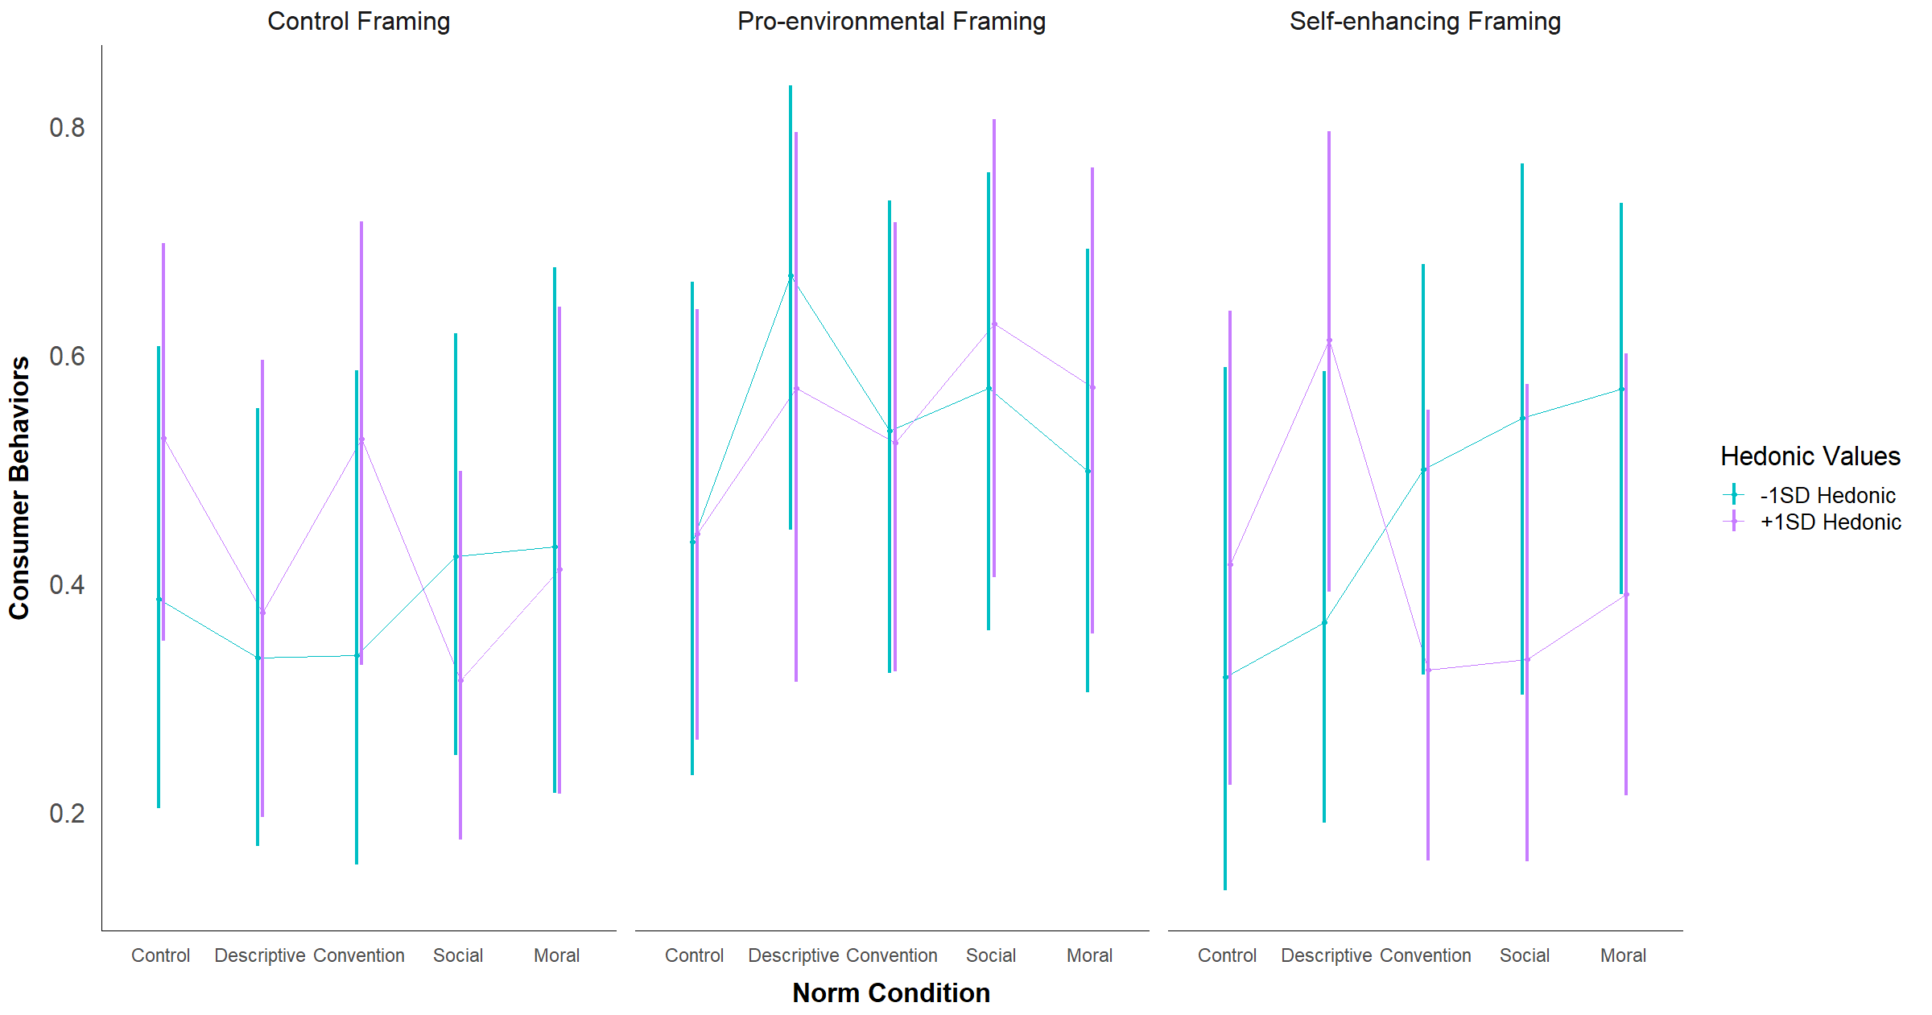

The pattern of the two-way interaction effects involving hedonic values somewhat differed from what was observed in the consumer intentions analysis. As shown in Table #, in the control framing condition, the odds of choosing the pro-environmental consumer behavior option were non-significantly higher among people high versus low on hedonic values, whereas this effect was in the opposite direction for pro-environmental consumer intentions. There was almost no difference between people high and low on hedonic values in the pro-environmental and self-enhancing framing conditions.

**Table #**

*Comparison of Consumer Behaviors Between People Low and High on Hedonic Values across Framing Conditions*

| Contrast | *Odds Ratio* | *95%CI*  *Odds Ratio* | *SE* | *z* | *p* |
| --- | --- | --- | --- | --- | --- |
| C framing: High Hed - Low Hed | 1.22 | [0.65, 2.26] | 0.39 | 0.62 | 0.536 |
| PE framing: High Hed - Low Hed | 1.02 | [0.54, 1.94] | 0.34 | 0.06 | 0.952 |
| SE framing: High Hed - Low Hed | 0.84 | [0.43, 1.62] | 0.28 | -0.53 | 0.599 |

*Note.* C = control, PE = pro-environmental, SE = self-enhancing

For the norm condition by hedonic values interaction, the main differences from the consumer intentions analysis were observed in the effects of the control norm, descriptive norm, and convention conditions. In the control and descriptive norm conditions, the odds of choosing the pro-environmental consumer behavior option were non-significantly higher among people high versus low on hedonic values (see Table #). There was no difference between the two groups in the convention condition.

**Table #**

*Comparison of Consumer Behaviors Between People Low and High on Hedonic Values across Norm Conditions*

| Contrast | *Odds Ratio* | *95%CI*  *Odds Ratio* | *SE* | *z* | *p* |
| --- | --- | --- | --- | --- | --- |
| Control norm: High Hed - Low Hed | 1.41 | [0.61, 3.27] | 0.60 | 0.80 | 0.425 |
| Descriptive: High Hed - Low Hed | 1.29 | [0.54, 3.09] | 0.57 | 0.57 | 0.567 |
| Convention: High Hed - Low Hed | 1.00 | [0.45, 2.23] | 0.41 | 0.01 | 0.995 |
| Social norm: High Hed - Low Hed | 0.69 | [0.30, 1.59] | 0.29 | -0.86 | 0.388 |
| Moral norm: High Hed - Low Hed | 0.84 | [0.39, 1.85] | 0.34 | -0.42 | 0.672 |

The pattern of the three-way interaction between hedonic values, framing condition, and norm condition was most similar to the consumer intentions analysis in the self-enhancing framing condition. The only difference was observed in the effect of the convention condition, in which, for people high on hedonic values, the odds of choosing the pro-environmental consumer behavior option were non-significantly lower compared to people low on hedonic values (see Table #).

In the pro-environmental framing condition, the pattern of the effects of each norm-intervention condition were opposite what was observed in the consumer intentions analysis for both people low and high on hedonic values. For both people low and high on hedonic values, exposure to each norm-intervention condition non-significantly improved their odds of choosing the pro-environmental consumer behavior option. In the consumer intentions analysis, each of the norm-intervention conditions in the pro-environmental framing condition non-significantly decreased, or had no effect on, these participants’ pro-environmental consumer intentions.

In the control framing conditions, the main differences from the results in the previous analysis were that, for people low on hedonic values, the social and moral norm conditions non-significantly improved their odds of choosing the pro-environmental consumer behavior option. For people high on hedonic values, the main difference was that the descriptive norm non-significantly decreased these individuals’ odds of choosing the pro-environmental consumer behavior option, and the convention condition had no effect.

**Table #**

*Effect of Each Norm Condition at Low and High Hedonic Values Across Framing Conditions*

| Framing Condition | Level of Values | Contrast of Norm Conditions | *Odds Ratio* | *95%CI  Odds Ratio* | *SE* | *z* | *p* |
| --- | --- | --- | --- | --- | --- | --- | --- |
| Control | -1SD Hedonic | Descriptive vs Control | 0.80 | [0.22, 2.86] | 0.52 | -0.34 | 0.733 |
| Convention vs Control | 0.81 | [0.21, 3.16] | 0.56 | -0.31 | 0.759 |
| Social vs Control | 1.17 | [0.35, 3.85] | 0.71 | 0.26 | 0.798 |
| Moral vs Control | 1.21 | [0.31, 4.66] | 0.83 | 0.28 | 0.783 |
| +1SD Hedonic | Descriptive vs Control | 0.54 | [0.17, 1.72] | 0.32 | -1.05 | 0.295 |
| Convention vs Control | 1.00 | [0.33, 2.99] | 0.56 | 0.00 | 0.996 |
| Social vs Control | 0.41 | [0.14, 1.19] | 0.22 | -1.64 | 0.101 |
| Moral vs Control | 0.63 | [0.19, 2.07] | 0.38 | -0.76 | 0.446 |
| PE | -1SD Hedonic | Descriptive vs Control | 2.62 | [0.70, 9.74] | 1.76 | 1.44 | 0.151 |
| Convention vs Control | 1.48 | [0.41, 5.37] | 0.97 | 0.60 | 0.551 |
| Social vs Control | 1.72 | [0.48, 6.15] | 1.12 | 0.83 | 0.404 |
| Moral vs Control | 1.28 | [0.37, 4.42] | 0.81 | 0.40 | 0.692 |
| +1SD Hedonic | Descriptive vs Control | 1.67 | [0.44, 6.29] | 1.13 | 0.76 | 0.449 |
| Convention vs Control | 1.38 | [0.43, 4.36] | 0.81 | 0.54 | 0.588 |
| Social vs Control | 2.11 | [0.63, 7.02] | 1.29 | 1.22 | 0.223 |
| Moral vs Control | 1.67 | [0.51, 5.47] | 1.01 | 0.85 | 0.393 |
| SE | -1SD Hedonic | Descriptive vs Control | 1.24 | [0.30, 5.17] | 0.90 | 0.29 | 0.771 |
| Convention vs Control | 2.14 | [0.56, 8.18] | 1.46 | 1.11 | 0.266 |
| Social vs Control | 2.56 | [0.57, 11.59] | 1.97 | 1.22 | 0.221 |
| Moral vs Control | 2.84 | [0.75, 10.81] | 1.94 | 1.53 | 0.126 |
| +1SD Hedonic | Descriptive vs Control | 2.22 | [0.62, 7.95] | 1.44 | 1.23 | 0.220 |
| Convention vs Control | 0.67 | [0.18, 2.49] | 0.45 | -0.60 | 0.551 |
| Social vs Control | 0.70 | [0.18, 2.68] | 0.48 | -0.52 | 0.605 |
| Moral vs Control | 0.90 | [0.26, 3.12] | 0.57 | -0.17 | 0.867 |

*Note.* PE = pro-environmental, SE = self-enhancing

***In-group identification effects.*** In the overall model, in-group identification did not significantly predict consumer behaviors, *F*(1, 8926.29) = 0.01, *p* = .938. There was no significant difference in the odds of choosing the pro-environmental consumer behavior option between people high and low on in-group identification, *OR* = 1.02, *z* = 0.14, *p* = .888, 95%CI[0.76, 1.36].

There was no significant two-way interaction between in-group identification and framing condition, *F*(2, 18834.69) = 0.11, *p* = .901, or between in-group identification and norm condition, *F*(4, 9488.21) = 0.24, *p* = .916. The three-way interaction between in-group identification, framing condition, and norm condition was also non-significant, *F*(8, 830.24) = 0.42, *p* = .909. Simple effects analyses were performed to examine the nature of these interaction effects further. The EMPs for each condition are visualized in Figure # below.

For both people high and low on in-group identification, the odds of choosing the pro-environmental consumer behavior option were highest in the pro-environmental framing condition (see Figure #). This is the same as what was observed for consumer intentions. For people high on in-group identification, the difference between the pro-environmental and control framing conditions, *p* = .008, and between the pro-environmental and self-enhancing conditions, *p* = .046 were significant, while the same comparisons were non-significant among people low on in-group identification. Additionally, though the odds of choosing the pro-environmental consumer behavior were higher in the self-enhancing compared to the control framing condition, this difference was not significant in either group.

**Table #**

*Effect of Each Framing Condition at Low and High In-group Identification*

| Level of  In-group Identification | Contrast | *Odds Ratio* | *95%CI  Odds Ratio* | *SE* | *z* | *p* |
| --- | --- | --- | --- | --- | --- | --- |
| -1SD In-group Identification | PE vs Control | 1.62 | [1.00, 2.64] | 0.40 | 1.95 | 0.051 |
| SE vs Control | 1.11 | [0.68, 1.81] | 0.28 | 0.40 | 0.689 |
| PE vs SE | 1.47 | [0.90, 2.41] | 0.37 | 1.52 | 0.128 |
| +1SD In-group Identification | PE vs Control | 1.91 | [1.19, 3.08] | 0.47 | 2.66 | 0.008 |
| SE vs Control | 1.16 | [0.72, 1.87] | 0.28 | 0.60 | 0.551 |
| PE vs SE | 1.65 | [1.01, 2.70] | 0.42 | 1.99 | 0.046 |

*Note.* PE = pro-environmental, SE = self-enhancing

**Figure #**

*Visualization of the EMPs at Low and High In-group Identification Across Framing Conditions*

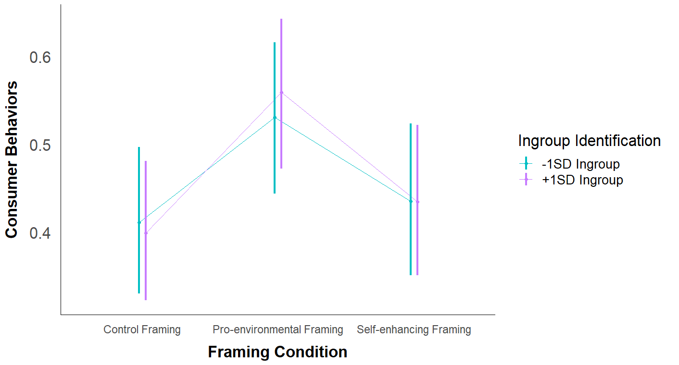

The pattern of effects of each norm-intervention condition at each level of in-group identification were different from what was observed in the analysis of consumer intentions. As seen in Figure #, for both people low and high on in-group identification, the odds of choosing the pro-environmental consumer behavior option were non-significantly higher in most of the norm-intervention conditions compared to the control norm condition (see Table #). In the previous analysis, most of the norm-intervention conditions non-significantly decreased pro-environmental consumer intentions for both groups.

**Table #**

*Effect of Each Norm-Intervention Condition at Low and High In-group Identification*

| Level of  In-group Identification | Contrast | *Odds Ratio* | *95%CI  Odds Ratio* | *SE* | *Z* | *p* |
| --- | --- | --- | --- | --- | --- | --- |
| -1SD In-group Identification | Descriptive vs Control | 1.43 | [0.76, 2.68] | 0.46 | 1.12 | 0.262 |
| Convention vs Control | 1.31 | [0.71, 2.43] | 0.41 | 0.85 | 0.393 |
| Social vs Control | 1.24 | [0.68, 2.25] | 0.38 | 0.70 | 0.486 |
| Moral vs Control | 1.54 | [0.83, 2.88] | 0.49 | 1.36 | 0.173 |
| +1SD In-group Identification | Descriptive vs Control | 1.21 | [0.66, 2.22] | 0.37 | 0.61 | 0.544 |
| Convention vs Control | 1.02 | [0.54, 1.93] | 0.33 | 0.05 | 0.959 |
| Social vs Control | 1.19 | [0.63, 2.21] | 0.38 | 0.53 | 0.593 |
| Moral vs Control | 1.04 | [0.56, 1.95] | 0.33 | 0.14 | 0.893 |

**Figure #**

*Visualization of the EMPs at Low and High In-group Identification Across Norm Conditions*

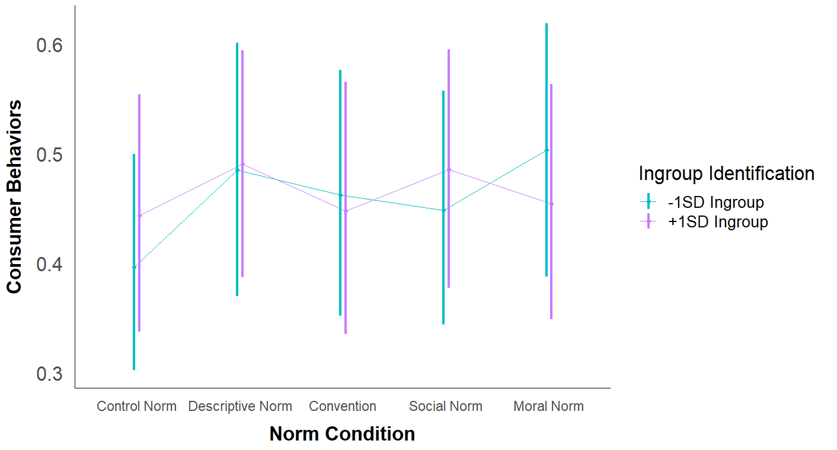

***Exploratory analyses.*** Similarly to the previous analysis, since the last two research questions are exploratory and involve multiple comparisons, Sidak-adjusted *p*-values and 95%CIs were calculated for the simple effects analyses. First, I investigated the three-way interaction effect between in-group identification, framing, and norm condition. The EMPs for each condition are given in Table # and visually displayed in Figure #.

**Table #**

*Estimated Marginal Probabilities for Consumer Behaviors at Low and High In-group Identification across Framing and Norm Conditions*

|  | Framing Condition | | | | | |  | |
| --- | --- | --- | --- | --- | --- | --- | --- | --- |
|  | Control | | Pro-environmental | | Self-enhancing | | Per  Norm Condition | |
| Norm Condition | Low | High | Low | High | Low | High | Low | High |
| Control | 0.39 (0.08) | 0.52 (0.09) | 0.46 (0.09) | 0.42 (0.10) | 0.34 (0.09) | 0.39 (0.09) | 0.40 (0.05) | 0.44 (0.06) |
| Descriptive Norm | 0.32 (0.10) | 0.39 (0.09) | 0.62 (0.10) | 0.62 (0.10) | 0.52 (0.09) | 0.46 (0.08) | 0.48 (0.06) | 0.49 (0.05) |
| Convention | 0.52 (0.10) | 0.34 (0.09) | 0.50 (0.09) | 0.56 (0.09) | 0.37 (0.10) | 0.45 (0.11) | 0.46 (0.06) | 0.45 (0.06) |
| Social Norm | 0.37 (0.07) | 0.36 (0.08) | 0.55 (0.10) | 0.64 (0.09) | 0.42 (0.11) | 0.45 (0.10) | 0.45 (0.06) | 0.49 (0.06) |
| Moral Norm | 0.45 (0.11) | 0.39 (0.09) | 0.52 (0.10) | 0.55 (0.10) | 0.54 (0.10) | 0.42 (0.10) | 0.50 (0.06) | 0.45 (0.06) |
| Per Framing Condition | 0.41 (0.04) | 0.40 (0.04) | 0.53 (0.04) | 0.56 (0.04) | 0.44 (0.04) | 0.43 (0.04) |  |  |

*Note.* This table reports EMPs for consumer behaviors (0 = new clothing, 1 = secondhand clothing) at low (-1SD) biospheric values and high (+1SD) biospheric values across framing and norm conditions. Standard errors are reported in parentheses.

**Figure #**

*Visualization of EMPs for Low vs High In-group Identification across Framing and Norm Conditions*

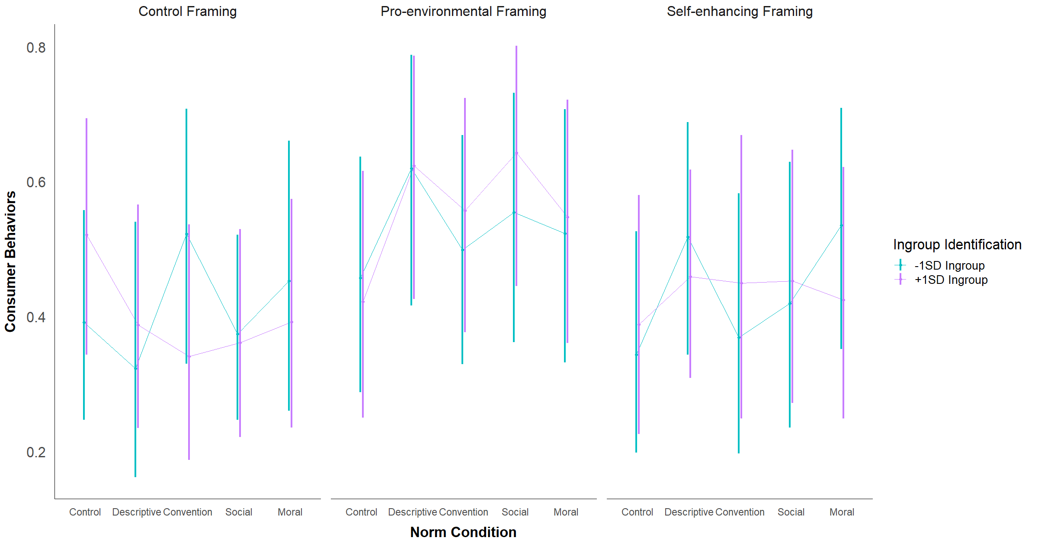

Table # examines the effect of each norm-intervention condition across each framing condition separately for participants low and high on in-group identification.

**Table #**

*Effect of Each Norm-Intervention Condition at Low and High In-group Identification Across Framing Conditions*

| Framing Condition | Level of Values | Contrast of Norm Conditions | *Odds Ratio* | *95%CI  Odds Ratio* | *SE* | *z* | *Sidak-adjusted p* |
| --- | --- | --- | --- | --- | --- | --- | --- |
| Control | -1SD In-group | Descriptive vs Control | 0.74 | [0.16, 3.51] | 0.42 | -0.52 | 0.999 |
| Convention vs Control | 1.70 | [0.40, 7.25] | 0.90 | 1.00 | 0.954 |
| Social vs Control | 0.93 | [0.26, 3.28] | 0.43 | -0.16 | 1.000 |
| Moral vs Control | 1.29 | [0.28, 5.90] | 0.72 | 0.45 | 1.000 |
| +1SD In-group | Descriptive vs Control | 0.58 | [0.14, 2.43] | 0.31 | -1.03 | 0.943 |
| Convention vs Control | 0.47 | [0.10, 2.16] | 0.26 | -1.34 | 0.796 |
| Social vs Control | 0.52 | [0.13, 2.10] | 0.27 | -1.28 | 0.833 |
| Moral vs Control | 0.59 | [0.14, 2.47] | 0.31 | -1.00 | 0.953 |
| PE | -1SD In-group | Descriptive vs Control | 1.93 | [0.42, 8.91] | 1.08 | 1.17 | 0.889 |
| Convention vs Control | 1.18 | [0.29, 4.86] | 0.61 | 0.32 | 1.000 |
| Social vs Control | 1.48 | [0.33, 6.55] | 0.81 | 0.71 | 0.994 |
| Moral vs Control | 1.30 | [0.29, 5.84] | 0.72 | 0.48 | 1.000 |
| +1SD In-group | Descriptive vs Control | 2.26 | [0.48, 10.76] | 1.29 | 1.43 | 0.736 |
| Convention vs Control | 1.72 | [0.39, 7.65] | 0.94 | 0.99 | 0.954 |
| Social vs Control | 2.46 | [0.52, 11.74] | 1.41 | 1.57 | 0.629 |
| Moral vs Control | 1.65 | [0.36, 7.54] | 0.92 | 0.90 | 0.974 |
| SE | -1SD In-group | Descriptive vs Control | 2.05 | [0.48, 8.71] | 1.09 | 1.36 | 0.786 |
| Convention vs Control | 1.12 | [0.23, 5.54] | 0.66 | 0.19 | 1.000 |
| Social vs Control | 1.38 | [0.29, 6.67] | 0.80 | 0.56 | 0.999 |
| Moral vs Control | 2.20 | [0.50, 9.61] | 1.19 | 1.45 | 0.717 |
| +1SD In-group | Descriptive vs Control | 1.34 | [0.33, 5.40] | 0.68 | 0.57 | 0.999 |
| Convention vs Control | 1.29 | [0.25, 6.70] | 0.78 | 0.42 | 1.000 |
| Social vs Control | 1.31 | [0.28, 6.15] | 0.74 | 0.47 | 1.000 |
| Moral vs Control | 1.16 | [0.25, 5.44] | 0.66 | 0.27 | 1.000 |

*Note.* PE = pro-environmental framing, SE = self-enhancing framing, Sidak-adjusted *p*-values and 95%CIs reported

For the second exploratory research question, each combination of pro-environmental and self-enhancing framing with each of the norm-intervention conditions was compared to the control framing/control norm condition. The EMPs for each condition were given earlier in the chapter in Table # and shown in Figure #.

Unlike what was observed in the analysis of consumer intentions, the combination of framing and norm conditions that produced the highest odds of choosing the pro-environmental consumer behavior option compared to the control framing/control norm condition were the pro-environmental framing/descriptive norm condition and the pro-environmental framing/social norm condition, though neither comparison was significant (see Table #). Similarly to the previous analysis, the self-enhancing framing/control norm condition produced the lowest odds of the pro-environmental consumer behavior option being chosen, though the difference between this condition and the control framing/control norm condition was not significant.

**Table #**

*Each Combination of Framing/Norm Condition Compared to the Control Framing/Control Norm Condition*

| Contrast with the  Control Framing/Control Norm Condition | *Odds Ratio* | *95%CI*  *Odds Ratio* | *SE* | *z* | *Sidak-adjusted p* |
| --- | --- | --- | --- | --- | --- |
| PE + Control Norm | 0.94 | [0.33, 2.65] | 0.35 | -0.17 | 1.000 |
| PE + Descriptive Norm | 1.96 | [0.62, 6.20] | 0.81 | 1.64 | .659 |
| PE + Convention | 1.34 | [0.49, 3.66] | 0.48 | 0.81 | .996 |
| PE + Social Norm | 1.79 | [0.60, 5.33] | 0.70 | 1.49 | .771 |
| PE + Moral Norm | 1.38 | [0.49, 3.86] | 0.51 | 0.86 | .993 |
| SE + Control Norm | 0.69 | [0.23, 2.03] | 0.27 | -0.96 | .983 |
| SE + Descriptive Norm | 1.14 | [0.42, 3.13] | 0.41 | 0.37 | 1.000 |
| SE + Convention | 0.83 | [0.28, 2.42] | 0.32 | -0.50 | 1.000 |
| SE + Social Norm | 0.92 | [0.32, 2.71] | 0.35 | -0.21 | 1.000 |
| SE + Moral Norm | 1.10 | [0.38, 3.17] | 0.42 | 0.25 | 1.000 |

*Note.* PE = pro-environmental framing, SE = self-enhancing framing, Sidak-adjusted *p*-values and 95%CIs reported